CSS GENDER STUDIES
T3KB
The Knowledge Base
Topic 3 · Feminist Movements — the West, the United Nations and Pakistan, taught from zero
WHAT THIS DOCUMENT GIVES YOU
◆ Syllabus Head IV taught from zero in simple English — the four waves of Western feminism, the United Nations and women, and the women's movement in Pakistan
◆ Each wave with its principles, goals, strategies, leaders, achievements and blind spots
◆ The four UN World Conferences, CEDAW, Beijing and its reviews, UN Women and SDG 5
◆ Pakistan phase by phase — from the Pakistan Movement, APWA and WAF to the Aurat March, digital activism and the NGO-isation debate
◆ Evidence inside every point, diagrams, today's debates, the examiner's record and five likely questions
◆ About 120 MCQ-style one-liners, every past MCQ on the topic, and a detailed revision sheet for exam night
Federal Public Service Commission · CSS Competitive Examination · Optional paper, 100 marks
Written for CE-2027 onwards · Record: CE-2016 to CE-2026 · Facts current to September 2026

Contents
HOW TO BUILD THE CONTENTS
The contents list below fills itself in. When Word asks "This document contains fields that may refer to other files. Update the fields?", click Yes.
If it does not ask: right-click the grey contents area → Update Field → Update entire table → OK. On a Mac, Control-click the same area. Or press Ctrl + A, then F9 (Windows), to update every field at once. Repeat after any edit, before you export to PDF.

Right-click here and choose Update Field to build the contents.

How to Use This Document

What this topic covers
Topic 3 is syllabus Head IV — Feminist Movements. It has three strands:
1. the waves of feminism in the West — first, second, third and (since about 2012) fourth;
2. the United Nations and women — the world conferences, CEDAW and the global agenda;
3. the women's movement in Pakistan — from the Pakistan Movement to the Aurat March.
Topic 2 taught the theories of feminism. This topic teaches the movements — the people, organisations, campaigns, protests and laws through which those ideas changed the world.
In the descriptive paper Topic 3 has had 9.5 visits in eleven papers: nine full questions and one short note. Two families carry it. The waves have been asked five times (with one exact repeat, 2019 and 2023). The movement in Pakistan has been asked four times, plus a note on APWA and WAF and a question on NGO-isation (2026). It also supplies 22 of the 140 MCQs — mostly dates: APWA 1949, Hudood 1979, CEDAW 1996, Beijing 1995.

How this document is built
1. Part Zero gives you the words of the topic, the wave metaphor and its critics, and the whole topic on one timeline.
2. Part One has eleven chapters: four on the waves, one comparing them, one on the United Nations, three on Pakistan (roots, phases, the influence of the West), one on NGO-isation and one evaluating the movement.
3. Part Two sets out today's debates.
4. Part Three lists every past question, what the record shows, and five likely questions.
5. Part Four is a bank of about 120 numbered one-liners in the style of the past MCQs, followed by every past MCQ on the topic.
6. Part Five is the revision sheet — the whole topic in a few pages, every word explained.
IN SIMPLE WORDS
A movement is many people working together, over years, to change society. Feminism as a movement has come in bursts of energy — the "waves" — each with its own demands. Learn each wave by what women lacked, what they demanded, how they campaigned and what they won.

Part Zero — The ABC of Topic 3

0.1 The words of this topic
Table 1 · The key terms of Topic 3 (★ = you must be able to define it in one sentence).
Term | Simple meaning, with an example
Women's movement ★ | Collective, organised action by women (and men) over time to improve women's rights and status.
Wave ★ | A period of intense feminist activity with shared demands. The first wave fought for the vote.
Suffrage ★ | The right to vote in public elections. New Zealand gave women suffrage in 1893.
Suffragist | A campaigner for votes for women using peaceful, legal methods (petitions, meetings).
Suffragette | A British campaigner of the WSPU who used militant methods (window-smashing, hunger strikes).
Legal personhood | Being recognised by law as a person who can own property, sign contracts and go to court.
Coverture | The old English rule that a married woman's legal identity was covered by her husband's.
Reproductive rights ★ | The right to decide whether and when to have children, with access to contraception and safe care.
Consciousness-raising | Women meeting in small groups to discover that private problems are political.
Backlash | A reaction against feminist gains (Susan Faludi, Backlash, 1991).
Postfeminism | The claim that equality has been won and feminism is no longer needed.
Hashtag activism ★ | Campaigning through social media tags. #MeToo (2017).
CSW | The UN Commission on the Status of Women, founded in 1946.
CEDAW ★ | The Convention on the Elimination of All Forms of Discrimination against Women (1979) — "an international bill of rights for women" (MCQ 2026). Pakistan acceded in 1996.
Accession / ratification | Two ways a state becomes bound by a treaty. Accession = joining a treaty already in force without having signed it first.
Reservation | A statement by which a state excludes or limits part of a treaty for itself.
Beijing Platform for Action ★ | The plan adopted at the Fourth World Conference on Women (1995), with 12 critical areas of concern.
Gender mainstreaming ★ | Putting a gender perspective into all policies and programmes, not only "women's projects".
APWA ★ | All Pakistan Women's Association, founded in 1949 by Begum Ra'ana Liaquat Ali Khan — welfare and reform.
WAF ★ | Women's Action Forum, founded in 1981 to resist Zia-ul-Haq's discriminatory laws.
Hudood Ordinances ★ | Laws of 1979 on zina, theft, drinking and false accusation; criticised for punishing rape victims.
Aurat March ★ | Annual women's march held on 8 March in Pakistani cities since 2018.
NGO-isation ★ | The shift of a social movement into professional, donor-funded NGOs, often said to depoliticise it.
Bodily autonomy | A person's right to decide about their own body. The Aurat March slogan "Mera Jism Meri Marzi".
State feminism | Women's rights advanced through the state — ministries, commissions, laws — rather than street protest.

0.2 The wave metaphor — and its critics
The American journalist Martha Weinman Lear wrote of "The Second Feminist Wave" in the New York Times Magazine in 1968. The earlier campaign for the vote then became the "first wave". Later activists spoke of a third (1992) and a fourth (c. 2012).
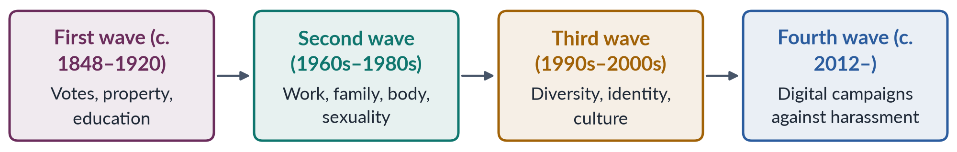
Figure 1 · The four waves in one line.
BALANCED VIEW · IS THE WAVE METAPHOR USEFUL?
• For: it gives a simple map of changing demands, and each wave did have its own leaders, methods and gains.
• Against: it follows white, Western, middle-class history; it hides activism between the waves (the "doldrums" of the 1920s–50s were full of campaigns for peace, labour and birth control); it makes each generation seem to reject the one before; and it ignores feminisms in Asia, Africa and Latin America, whose timing was different.
➜ Use the waves as a map, not a law. In Pakistan, the "waves" arrived in a different order and mixed together (Chapter 9).

0.3 The whole topic on one timeline
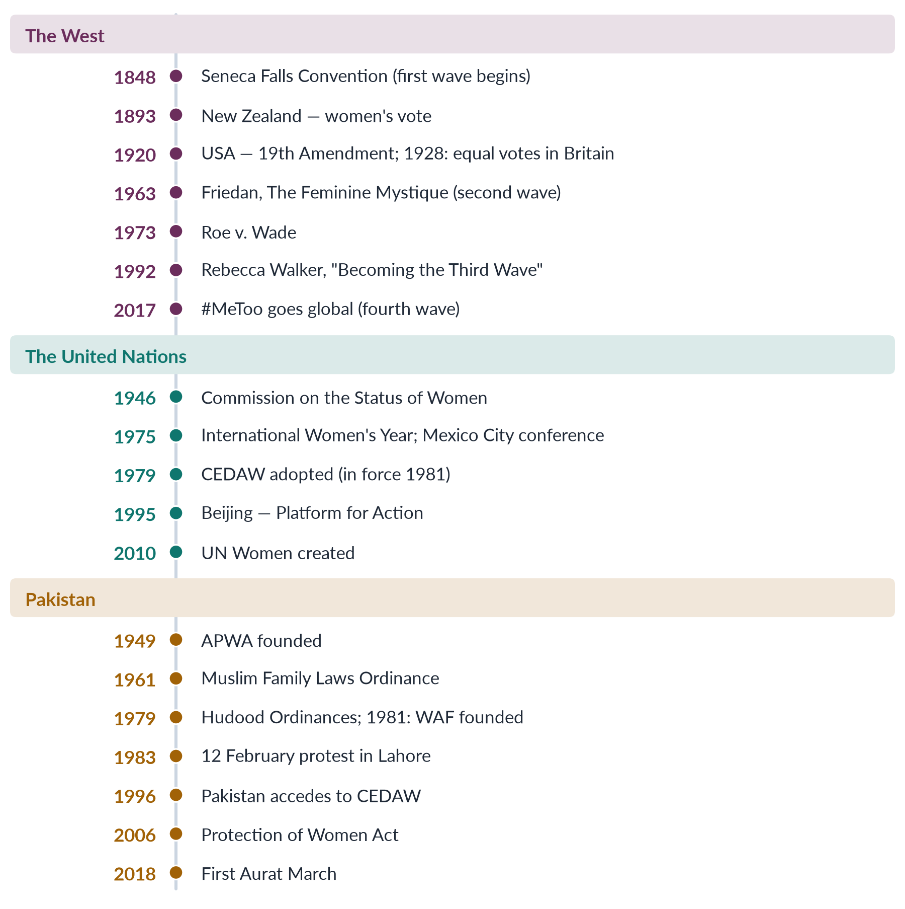
Figure 2 · Topic 3 on one page: the West, the United Nations and Pakistan.
EXAMINER'S EYE · HOW THE EXAMINER USES THIS TOPIC
Four of the five questions on the waves also ask how they influenced Pakistan or affected women's lives. Every question on Pakistan comes with a twist: strengths and weaknesses (2016), past versus emerging trends (2024), the shift from legal rights to bodily autonomy (2026), and NGO-isation (2026). Western history alone is half an answer. Always carry the story to Pakistan, and always evaluate.

Part One — The Movements

Chapter 1 · The First Wave (c. 1848–1920): Votes and Legal Personhood
The first wave was the long struggle of the nineteenth and early twentieth centuries for women's legal existence: the right to vote, to own property, to be educated and to enter the professions. It was asked with the third wave in 2022 ("Shed light on the first wave and third wave") and in every question on the waves.

1.1 What women lacked
In the early nineteenth century, in Britain and the United States:
- women could not vote or stand for Parliament or Congress;
- under coverture, a married woman's legal identity was "covered" by her husband's — she could not own property, sign contracts or keep her own wages;
- women were barred from universities and from professions such as law and medicine;
- in divorce, custody of children usually went to the father.
IN SIMPLE WORDS
A married woman in 1840 was, in law, almost like a child. Her husband owned her earnings, her property and, in effect, her person. The first wave was about making women legal persons and citizens.

1.2 The roots
- The ideas came from the Enlightenment and the revolutions of America (1776) and France (1789), which proclaimed the "rights of man". Olympe de Gouges answered with a Declaration of the Rights of Woman (1791), and Mary Wollstonecraft with A Vindication of the Rights of Woman (1792).
- The practical training came from the anti-slavery movement. Women learnt to organise, petition and speak in public for enslaved people — and then noticed their own lack of rights.

1.3 The United States
✦ CASE
The World Anti-Slavery Convention, London (1840) · the spark
American delegates Elizabeth Cady Stanton and Lucretia Mott travelled to London for the convention, but as women they were refused seats and made to sit behind a curtain. They resolved to hold a convention on the rights of women.
➜ A 2024 MCQ asked who was excluded from this convention and resolved to hold Seneca Falls: Stanton and Mott.

✦ CASE
The Seneca Falls Convention (19–20 July 1848) · the start of the first wave
About 300 people met at Seneca Falls, New York. The Declaration of Sentiments, drafted by Stanton on the model of the Declaration of Independence, declared: "We hold these truths to be self-evident: that all men and women are created equal." It listed women's grievances and passed resolutions, the most controversial being the demand for the vote. About 100 people signed, among them the abolitionist Frederick Douglass.
➜ A 2025 MCQ asked who led Seneca Falls: Elizabeth Cady Stanton.

- Susan B. Anthony and Stanton founded the National Woman Suffrage Association (1869); a rival American Woman Suffrage Association was formed the same year. They merged in 1890.
- Sojourner Truth's speech at Akron, Ohio (1851) reminded the movement of Black women.
- Wyoming Territory gave women the vote in 1869; other western states followed.
- Alice Paul's National Woman's Party picketed the White House (1917).
- The 19th Amendment to the US Constitution (ratified 1920) gave women the vote nationally.

1.4 Britain: suffragists and suffragettes
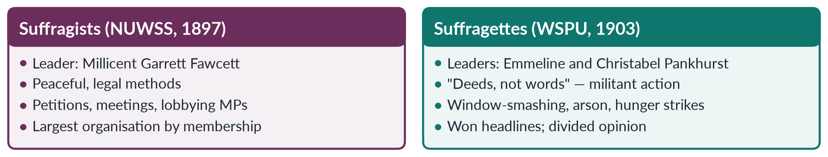
Figure 3 · Suffragists and suffragettes in Britain.
- John Stuart Mill asked Parliament in 1867 to give women the vote; he failed, but the campaign began.
- The Married Women's Property Acts (1870, 1882) let married women own property.
- Imprisoned suffragettes went on hunger strike and were force-fed; the "Cat and Mouse Act" (1913) released them when weak and re-arrested them when recovered.
- Emily Wilding Davison died after running onto the course at the Epsom Derby in 1913.
- The Representation of the People Act 1918 gave the vote to women over 30 who met a property qualification; the Equal Franchise Act 1928 gave it to women at 21, the same as men.
NOTE
Historians still argue whether militancy helped or hurt. Women's work in the First World War (1914–18) made refusing them the vote much harder, and the 1918 Act followed soon after.

1.5 The first wave around the world
Table 2 · When women won the national vote — a selection.
Country | Year | Note
New Zealand | 1893 | First self-governing country; campaign led by Kate Sheppard
Australia | 1902 | Federal vote, but Aboriginal women excluded until 1962
Finland | 1906 | First in Europe; women could also stand for parliament
Britain | 1918 / 1928 | Over 30 with property; then equal at 21
USA | 1920 | 19th Amendment
Turkey | 1934 | Under Atatürk's reforms
France | 1944 | After the Second World War
India and Pakistan | 1947 | Universal adult franchise at independence (Pakistan's first direct national election on adult franchise was in 1970)

1.5a More than the vote: the other first-wave campaigns
The vote was the symbol, but first-wave women fought on many fronts at once.
1. Custody of children. In Britain Caroline Norton, separated from a violent husband who kept her children, campaigned for the Custody of Infants Act 1839, which let mothers seek custody of young children.
2. Divorce. The Matrimonial Causes Act 1857 allowed divorce through the courts, though on unequal terms for wives.
3. Property. The Married Women's Property Acts of 1870 and 1882 ended coverture over property in Britain; American states passed similar laws from the 1840s.
4. Education. Elizabeth Blackwell became the first woman to earn a medical degree in the USA (1849); Girton College, Cambridge, opened for women in 1869; Elizabeth Garrett Anderson became the first woman to qualify as a doctor in Britain (1865).
5. The body and the state. Josephine Butler led the campaign against Britain's Contagious Diseases Acts, which allowed police to force suspected prostitutes into medical examination; the Acts were repealed in 1886.
6. Temperance. Many American women joined the campaign against alcohol, which they linked to domestic violence and poverty.
IN SIMPLE WORDS
Think of the first wave as a campaign to give women a legal existence: a vote, a bank account, a degree, a divorce, custody of their children. The vote was the last lock on the door.

1.5b Why the vote was finally won
1. Decades of organisation — petitions signed by hundreds of thousands, and national societies with branches everywhere.
2. Militancy — the suffragettes kept the issue in the headlines, though they also hardened opposition.
3. War work — during the First World War women worked in munitions factories, transport and nursing; the argument that women could not share civic duties collapsed.
4. Changing politics — the widening of men's suffrage made a sex bar harder to defend.
5. International example — New Zealand, Australia, Finland and Norway had already enfranchised women without disaster.

1.5c First-wave feminism in the Muslim world
The first wave was not only Western. In the early twentieth century, women in Muslim societies campaigned for education, reform of family law and the vote.
- In Egypt, Huda Shaarawi founded the Egyptian Feminist Union in 1923. Returning from an international women's conference in Rome that year, she removed her face veil in public at a Cairo railway station — a famous symbolic act. The Union campaigned for girls' education, a higher marriage age and limits on polygamy.
- In Turkey, Atatürk's reforms gave women the vote in national elections in 1934 and replaced religious family law with a civil code (1926).
- In Iran, women won the vote in 1963.
- In British India, Muslim women's journals and associations (Chapter 7) argued for education and against the abuse of purdah and polygamy.
These movements shared first-wave goals — legal status and education — but often argued in terms of Islamic reform and national progress rather than liberal individualism.

1.6 Principles, goals and strategies
Table 3 · The first wave in one table.
Aspect | First wave
Principles | Women are rational citizens with equal natural rights (liberal feminism)
Goals | The vote, property rights for married women, education, entry to professions, custody rights
Strategies | Conventions, petitions, lobbying, newspapers, marches; in Britain, militant direct action
Leaders | Stanton, Mott, Anthony, Truth (USA); Fawcett, the Pankhursts (Britain); Sheppard (New Zealand)
Main achievement | Legal personhood and citizenship for women

1.7 Achievements and limits
Achievements. Women won the vote in most Western countries by 1930; married women could own property; universities and professions slowly opened; women entered public life.
Limits.
1. Mostly white and middle-class. Some white suffragists used racist arguments; Black women in the American South were kept from voting until the Voting Rights Act of 1965.
2. Legal equality, not social equality. Once the vote was won, the organised movement lost its single goal. The family, work and sexuality were left almost untouched — the work of the second wave.
3. Western timing. In colonised countries, women's suffrage came with independence and the struggle for national freedom.
PAKISTAN ANGLE · THE FIRST WAVE AND PAKISTAN
Pakistani women did not need a separate suffrage struggle: the vote came with independence in 1947 and the Pakistan Movement itself (Chapter 7). But first-wave goals — education, property and legal status — shaped the early Pakistani movement: APWA's schools and colleges, the West Punjab Muslim Personal Law (Shariat) Application Act 1948 (inheritance for women, including in agricultural land), and the Muslim Family Laws Ordinance 1961.

Chapter 2 · The Second Wave (1960s–1980s): Work, Family, Body and Sexuality
Women had the vote, yet they were still paid less, kept at home, harassed at work and denied control over their bodies. The second wave took feminism from the ballot box into the office, the kitchen and the bedroom. Its slogan — "the personal is political" — was the key to a 2026 MCQ.

2.1 Why a second wave?
By the 1950s women in the West could vote, but:
- most professions and senior jobs were closed or hostile to them;
- women were paid far less for similar work, and job adverts were divided into "men" and "women";
- the "feminine mystique" said women should find fulfilment as housewives;
- contraception was restricted and abortion illegal in most places;
- rape in marriage, domestic violence and sexual harassment were not treated as crimes.
Several changes prepared the ground: women's work in the Second World War; rising numbers of women at university; the contraceptive pill (approved in the USA in 1960); the civil-rights movement, which taught tactics; and Simone de Beauvoir's The Second Sex (1949).

2.2 The two streams
The second wave had two main streams, which often disagreed (Topic 2 teaches their theories).
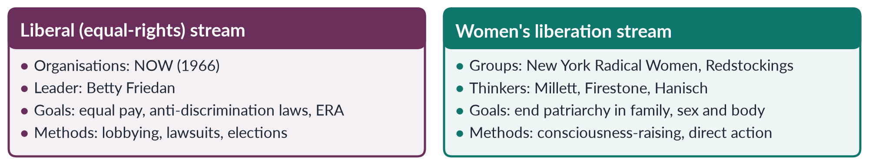
Figure 4 · The two streams of the second wave.
✦ THINKER
Betty Friedan · *The Feminine Mystique* (1963)
Friedan described "the problem that has no name" — the emptiness felt by educated suburban housewives — and co-founded the National Organization for Women (1966).
➜ The book that launched the liberal stream of the second wave.

2.3 Key events
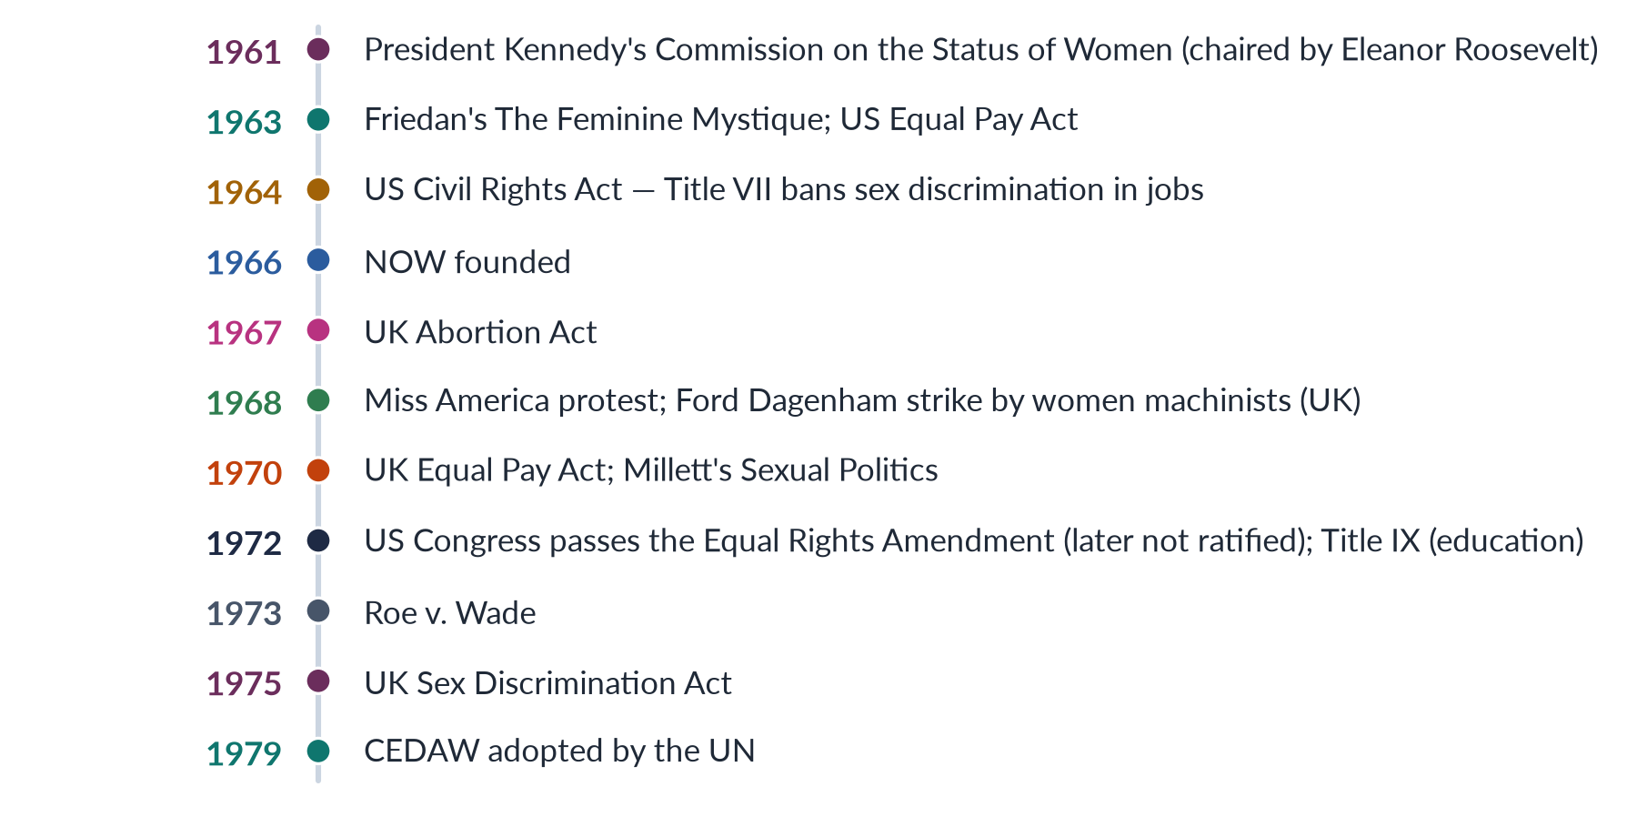
Figure 5 · The second wave in the United States and Britain.
✦ CASE
Roe v. Wade (22 January 1973) · the landmark of reproductive rights
The US Supreme Court held that the constitutional right to privacy covers a woman's decision to have an abortion, within limits. (A 2025 MCQ asked for this case.) In 2022 the Court overturned it in Dobbs v. Jackson Women's Health Organization, returning the question to the states — a sign that second-wave gains can be reversed.

2.3a The second wave beyond the United States
- Britain. The first National Women's Liberation Conference at Ruskin College, Oxford (1970), adopted four demands: equal pay; equal education and opportunity; 24-hour nurseries; and free contraception and abortion on demand. The women machinists' strike at Ford Dagenham (1968) led to the Equal Pay Act 1970.
- France. In the "Manifesto of the 343" (1971), 343 women, including Simone de Beauvoir, declared publicly that they had had illegal abortions; France legalised abortion in 1975.
- Iceland. On 24 October 1975 about 90% of Icelandic women stopped work for a day — cooking, childcare and paid jobs — to show their value. In 1980 Iceland elected Vigdís Finnbogadóttir, the world's first democratically elected woman president.
- The global South. Women in India, Latin America and Africa organised against dowry deaths, rape in custody, and military rule — often linking gender to class and nation.

2.3b The voices of the second wave
- Gloria Steinem co-founded Ms. magazine (1972), which brought feminist ideas to a mass readership.
- Germaine Greer (The Female Eunuch, 1970) argued that women had been cut off from their own energy and sexuality.
- Kate Millett and Shulamith Firestone (both 1970) gave the radical stream its theory.
- Angela Davis (Women, Race and Class, 1981) linked sexism to racism and capitalism.
- Audre Lorde and bell hooks challenged the movement from within to include Black women.

2.4 The main issues
1. Work and pay. Equal pay laws; opening of professions; the end of "help wanted — male/female" adverts.
2. Reproductive rights. Contraception and legal abortion.
3. Violence. Rape crisis centres and women's shelters (the first modern shelter opened in Chiswick, London, in 1971); campaigns against domestic violence.
4. Sexual harassment. Catharine MacKinnon (1979) argued it is sex discrimination; courts later agreed.
5. The family and housework. Unpaid domestic work, the double burden, childcare — the "personal is political" (Carol Hanisch, 1970).
6. Education. Title IX (1972) in the USA; the rise of Women's Studies (Cornell 1969, San Diego 1970).

2.4a What the second wave achieved, issue by issue
Table 4 · The second wave's main achievements.
Issue | Achievement
Pay and jobs | Equal Pay Acts (US 1963; UK 1970); Title VII (1964); UK Sex Discrimination Act (1975); professions opened
Reproduction | The pill (1960); Griswold v. Connecticut (1965) on contraception; UK Abortion Act (1967); Roe v. Wade (1973)
Violence | Rape crisis centres and shelters (from 1971); domestic violence and marital rape gradually criminalised
Harassment | Sexual harassment recognised as discrimination (MacKinnon 1979; US courts in the 1980s)
Education | Title IX (1972); Women's Studies programmes
Global | UN International Women's Year (1975); CEDAW (1979)

2.5 Principles, goals and strategies
Table 5 · The second wave in one table.
Aspect | Second wave
Principles | Legal equality is not enough; inequality lives in work, family, sexuality and culture; "the personal is political"
Goals | Equal pay and jobs; reproductive rights; ending violence and harassment; sharing housework; changing culture
Strategies | Lobbying and lawsuits (NOW); consciousness-raising; marches and sit-ins; shelters; Women's Studies
Leaders | Friedan, Steinem, Millett, Firestone, Hanisch, MacKinnon
Main achievement | Equal-pay and anti-discrimination laws; reproductive rights; violence against women made a public issue

✦ DEFINITION
The personal is political · the second wave's slogan
Problems that seem private — housework, marriage, sex, abortion, appearance — are shaped by power and can be changed by collective political action.
➜ A 2026 MCQ asked which wave this slogan is most associated with: the second wave.

2.5a Why the second wave faded
By the early 1980s the second wave had lost much of its momentum. Several reasons are usually given:
1. Success. Many legal goals — equal pay laws, anti-discrimination laws, legal abortion in many countries — had been won, so the movement lost its most visible targets.
2. Division. Liberal and radical feminists disagreed about strategy; Black and lesbian feminists felt excluded; the "sex wars" of the 1980s split feminists over pornography.
3. Conservative politics. The governments of Ronald Reagan (USA) and Margaret Thatcher (Britain) cut welfare spending and promoted traditional family values; the Equal Rights Amendment failed to be ratified by its 1982 deadline.
4. Institutionalisation. Many activists moved into universities, government and NGOs — feminism continued, but less on the streets.

2.6 Blind spots
1. White and middle-class. bell hooks (Ain't I a Woman, 1981) and Audre Lorde criticised the movement for treating the problems of white, educated women as every woman's. Friedan's "trapped housewife" was a luxury for women who had always had to work.
2. Heterosexual bias. Friedan once called lesbian activists a "lavender menace" (1969); lesbian feminists pushed back.
3. Western focus. Women of the global South had other priorities — food, land, water, anti-colonial struggle. At the UN conference in Mexico City (1975) these differences came into the open (Chapter 6).
4. Backlash. Phyllis Schlafly led the campaign that defeated the Equal Rights Amendment; Susan Faludi (Backlash, 1991) described a counter-attack in the 1980s.

2.7 How the second wave affected women's lives
- Women entered universities and professions in large numbers.
- Discrimination at work became unlawful, and pay gaps narrowed (though they did not close).
- Women gained control over when to have children.
- Domestic violence, rape and harassment became crimes to be prosecuted.
- The division of housework was questioned — though women still do more of it everywhere.
PAKISTAN ANGLE · THE SECOND WAVE AND PAKISTAN
The second wave reached Pakistan as the Women's Action Forum (1981). WAF's fight against the Hudood Ordinances (1979) — laws that exposed rape victims to charges of adultery — was a second-wave struggle over the body, sexuality and violence. So was the later work on domestic violence, harassment (Act of 2010) and honour crimes (2016). Its secular, middle-class leadership also shared the second wave's blind spot: difficulty reaching rural and working-class women (Chapter 9).

Chapter 3 · The Third Wave (1990s–2000s): Diversity, Identity and Culture
The third wave was led by young women who grew up with second-wave gains but saw that "women" were not one group. It stressed diversity, individual identity, sexuality and culture. The 2022 question asked for the first and third waves together; a 2025 MCQ asked who coined "Third Wave": Rebecca Walker.

3.1 The spark
✦ CASE
The Anita Hill hearings (October 1991) · the trigger
Law professor Anita Hill testified before an all-male US Senate committee that Clarence Thomas, nominated to the Supreme Court, had sexually harassed her. She was questioned harshly, and Thomas was confirmed. Many women were angered by how she was treated.

✦ THINKER
Rebecca Walker · "Becoming the Third Wave", *Ms.* magazine (January 1992)
Writing in response to the Hill hearings, the 22-year-old Walker declared: "I am not a post-feminism feminist. I am the Third Wave." She co-founded the Third Wave Direct Action Corporation (1992), which registered young voters.
➜ A 2025 MCQ asked who coined the term Third Wave feminism: Rebecca Walker (daughter of the novelist Alice Walker).

NOTE
The phrase "third wave" had appeared in a few earlier writings, but Walker's 1992 essay made it the name of a generation.

3.2 The ideas behind it
The third wave drew on three streams of theory taught in Topic 2:
1. Black feminism and intersectionality — bell hooks (1981, 1984), the Combahee River Collective (1977) and Kimberlé Crenshaw (1989) showed that gender overlaps with race, class and sexuality.
2. Postmodern and queer theory — Judith Butler (Gender Trouble, 1990) argued that gender is performative and that "woman" is not a fixed category.
3. Postcolonial feminism — Chandra Mohanty (1984) criticised Western feminists for speaking for "Third World women".

3.3 Main features
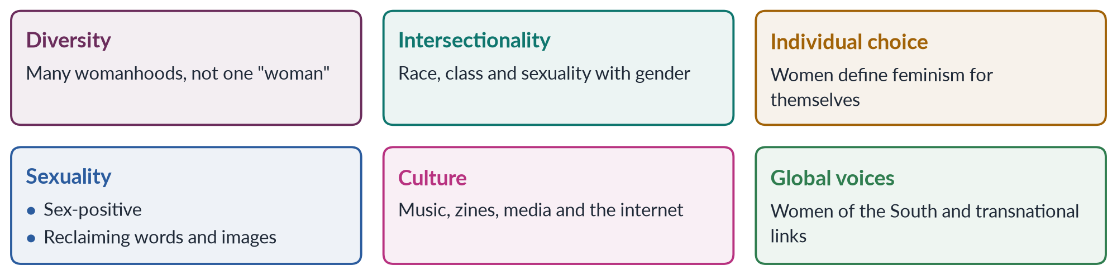
Figure 6 · Six features of the third wave.
- Riot Grrrl (from 1991, Olympia, Washington) — punk bands such as Bikini Kill (Kathleen Hanna) and handmade magazines ("zines") spread feminist messages among teenage girls.
- Naomi Wolf's The Beauty Myth (1990) showed how images of beauty control women.
- Eve Ensler's play The Vagina Monologues (1996) broke silence on women's bodies and violence; it led to the global V-Day campaign against violence.
- Jennifer Baumgardner and Amy Richards, Manifesta (2000), set out a young-feminist agenda.
- "Girl power" and the reclaiming of words once used as insults.
- Global feminism: the Beijing conference (1995) and the phrase "women's rights are human rights" linked Western and Southern activists.

3.3a Laws and campaigns of the third-wave era
- The Violence Against Women Act (USA, 1994) funded shelters and trained police and prosecutors.
- The Vienna World Conference on Human Rights (1993) declared women's rights to be human rights; the UN adopted the Declaration on the Elimination of Violence against Women the same year.
- Beijing (1995) linked activists from every continent; transnational networks grew by email and the early web.
- V-Day (from 1998) turned The Vagina Monologues into a global fundraising campaign against violence.
- Campaigns for workplace harassment policies spread after the Anita Hill hearings; complaints to the US Equal Employment Opportunity Commission rose sharply in the following years.

3.3b Postfeminism explained
Postfeminism is the idea that feminism's work is done: women can vote, study and work, so any remaining inequality is a matter of individual choice. Critics such as Angela McRobbie and Susan Faludi argued that this idea was itself a kind of backlash — it celebrated women's freedom to consume and look attractive while ignoring pay gaps, violence and the double burden. The third wave defined itself against postfeminism: Rebecca Walker's words "I am not a post-feminism feminist" say exactly this.
IN SIMPLE WORDS
Postfeminism says: "You are already equal — enjoy it." The third wave replied: "Some of us are equal in some ways — and many women are not equal at all."

3.4 Principles, goals and strategies
Table 6 · The third wave in one table.
Aspect | Third wave
Principles | Women are diverse; identities intersect; gender is constructed; individuals define their own feminism
Goals | Inclusion of women of colour, LGBT people and women of the South; sexual freedom; fighting violence and harassment; positive self-image; global human rights
Strategies | Culture (music, zines, art, media), voter registration, campus activism, early internet, transnational networks
Leaders and voices | Rebecca Walker, bell hooks, Kimberlé Crenshaw, Judith Butler, Naomi Wolf, Kathleen Hanna
Main achievement | Made feminism plural and inclusive; brought intersectionality into the mainstream

3.4a The third wave outside the West
In the 1990s, feminists in the global South built movements that shared third-wave themes of diversity and identity without copying the American style.
- Transnational networks such as DAWN and Women Living Under Muslim Laws (founded 1984) linked activists across countries, including Pakistan.
- Islamic feminism grew: Amina Wadud (Qur'an and Woman, 1992), Fatima Mernissi, and the Malaysian group Sisters in Islam (1988) argued for equality from within Islam.
- Violence became an international human-rights issue after Vienna (1993), with campaigns such as the 16 Days of Activism against Gender-Based Violence (from 1991).

3.5 Criticisms
1. Too individual. Stress on personal choice made it hard to organise around shared goals — "choice feminism" can call any choice feminist.
2. Consumerism. "Girl power" was easily turned into a marketing slogan for clothes and pop music.
3. Fragmentation. Without a single goal like the vote or equal pay, the movement was less visible.
4. Postfeminism. Critics such as Angela McRobbie argued that popular culture in the 2000s treated feminism as "already achieved" and no longer needed.
5. Break with the past? Some second-wave feminists felt their work was caricatured; historians see more continuity than the wave labels suggest.
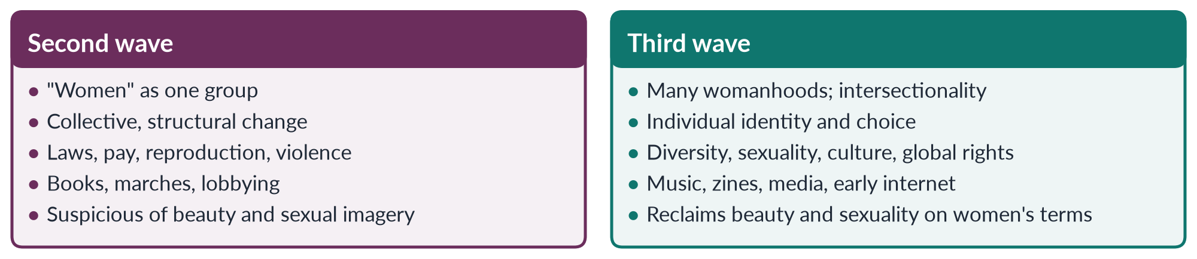
Figure 7 · Second wave and third wave.

3.6 How the third wave affected women's lives
- Women of colour, lesbian and transgender women and women of the global South gained voice in feminism.
- Intersectionality entered law, policy and research.
- Sexual harassment gained public attention after the Hill hearings; complaints rose.
- Global human-rights language — Vienna (1993), Beijing (1995) — made violence against women an international issue.
PAKISTAN ANGLE · THE THIRD WAVE AND PAKISTAN
Third-wave themes reached Pakistan in the 1990s and 2000s through three channels. First, the Beijing conference (1995), where Benazir Bhutto spoke, and the NGO boom that followed (Chapter 10). Second, diversity: attention to rural, minority and poor women, and later to khawaja siras (Supreme Court 2009; Act 2018). Third, Islamic feminism — scholars such as Riffat Hassan and Asma Barlas re-reading Islamic sources — which fits the third wave's rejection of one Western model of "the liberated woman".

Chapter 4 · The Fourth Wave (c. 2012 onwards): Digital Activism
Since about 2012 a new burst of feminist energy has used social media to expose harassment and violence, from the Everyday Sexism Project to #MeToo. The syllabus stops at three waves, but the 2025 question asked for "the different waves", the 2024 question for "emerging trends", and the 2026 question traced Pakistani activism to "the digital activism of the 2020s". You need the fourth wave.

4.1 Is there a fourth wave?
The British journalist Kira Cochrane (All the Rebel Women, 2013) argued that a fourth wave had begun, defined by technology. Most writers now accept the label, though some say it is simply the third wave online.
✦ DEFINITION
Fourth-wave feminism · the digital wave
Feminist activism since about 2012 that uses social media and the internet to share experiences, expose sexual harassment and violence, organise mass protests quickly and hold powerful men accountable, with a strong commitment to intersectionality.
➜ Key words: hashtag activism, #MeToo, online harassment, call-out culture, intersectionality, bodily autonomy.

4.2 Key campaigns
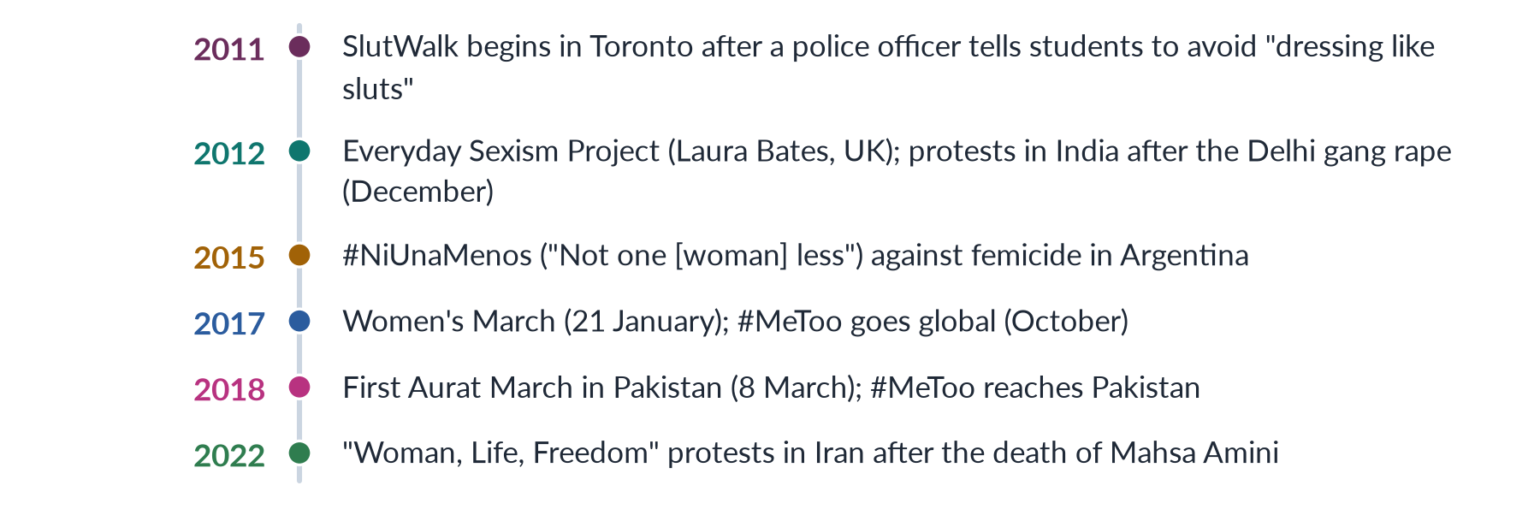
Figure 8 · The fourth wave in key campaigns.
✦ CASE
#MeToo · the defining campaign
The phrase "Me Too" was first used by the American activist Tarana Burke in 2006 to support survivors of sexual abuse. In October 2017, after newspaper reports on the film producer Harvey Weinstein, the actor Alyssa Milano invited women to reply "me too" if they had been harassed or assaulted. Millions did, in dozens of countries. Powerful men in film, media, politics and business lost their jobs; some were prosecuted.
➜ It showed the power of collective testimony: individual stories, shared at once, revealed a pattern.

4.2a The fourth wave around the world
The fourth wave was global from the start, and it changed laws in many countries.
Table 7 · Fourth-wave campaigns and the laws that followed.
Country | Campaign | Result
India | Protests after the Delhi gang rape (December 2012) | Criminal Law (Amendment) Act 2013 — tougher penalties, new offences such as stalking
Argentina | #NiUnaMenos (2015) and the "green wave" | Abortion legalised in December 2020
Ireland | "Repeal the Eighth" campaign | Referendum of 25 May 2018 removed the constitutional ban on abortion
South Korea | #MeToo (2018), led by a public prosecutor's testimony | Prosecutions of senior figures; debate on workplace culture
Spain | Protests over a gang-rape verdict (2018) | "Only yes means yes" consent law (2022)
Iran | "Woman, Life, Freedom" (from September 2022) | Mass protests against compulsory veiling; harsh state repression
Pakistan | Aurat March (from 2018); online campaigns | Anti-Rape Act 2021; cyber-harassment helplines; wide debate

IN SIMPLE WORDS
In the first wave a campaign took decades to cross an ocean. In the fourth wave a hashtag can cross every ocean in a day — which is why the same slogans appear in Buenos Aires, Delhi, Tehran and Lahore.

4.3 Main features
1. Digital tools. Hashtags, videos and online petitions let campaigns spread worldwide within days.
2. Focus on sexual harassment and violence — in streets, workplaces, universities and online.
3. Intersectionality as a starting principle, including transgender and non-binary people.
4. Bodily autonomy and consent.
5. Accountability — naming abusers ("call-out culture") and demanding institutional responses.
6. Global and fast. Campaigns from Argentina, India, Iran and Pakistan reached global audiences.

4.4 Principles, goals and strategies
Table 8 · The fourth wave in one table.
Aspect | Fourth wave
Principles | Intersectional, inclusive; consent and bodily autonomy; survivors should be believed and heard
Goals | End sexual harassment and violence; hold abusers and institutions accountable; equal pay; safe public and online spaces
Strategies | Hashtag campaigns, online testimony, viral videos, mass marches organised online, legal complaints
Voices | Tarana Burke, Laura Bates, Kira Cochrane; movements such as #NiUnaMenos and the Aurat March
Main achievement | Made harassment visible and costly; new workplace policies; laws on stalking, image abuse and cyber-harassment

4.5 Criticisms and risks
1. Online abuse. Women activists face threats, doxxing (publishing private details), fake images and coordinated attacks.
2. "Slacktivism". Clicking and sharing may replace sustained organising.
3. Due process. Critics warn that public accusations online can bypass courts and damage the innocent; supporters reply that formal systems have long failed survivors.
4. The digital divide. Poor and rural women — above all in countries like Pakistan — have less access to phones and the internet, so the wave can be urban and middle-class.
5. Backlash. The "manosphere" and anti-feminist influencers attract young men online (Topic 2, Chapter 6).
✦ DATA
Mobile-internet gender gap in Pakistan · GSMA, as cited in the CSS 2026 paper
The gap between men's and women's mobile-internet use fell from 38% to 25%, bringing about eight million more women online (2024–2025).
➜ Digital feminism in Pakistan is growing, but a quarter of the gap remains.

4.6 How the fourth wave affected women's lives
- Workplaces adopted harassment policies and complaint committees.
- Laws on online harassment, stalking and image-based abuse spread.
- Survivors found solidarity and a public voice.
- Young women worldwide learnt feminist ideas through social media.
PAKISTAN ANGLE · THE FOURTH WAVE IN PAKISTAN
• The Aurat March (from 8 March 2018), organised largely through social media by young, urban women, is Pakistan's fourth-wave movement. Its slogans on bodily autonomy — Mera Jism Meri Marzi — provoked fierce debate in 2019–2020.
• #MeToo reached Pakistan in 2018, with allegations in the entertainment industry that led to long defamation cases.
• Digital rights groups such as the Digital Rights Foundation (founded 2012) run a cyber-harassment helpline (from 2016); the Prevention of Electronic Crimes Act 2016 criminalises some online harassment.
• Online outrage after cases such as the killing of Qandeel Baloch (2016), the Lahore motorway gang rape (2020) and the murder of Noor Mukadam (2021) pushed the state to act — for example, the Anti-Rape (Investigation and Trial) Act 2021.

Chapter 5 · The Waves Compared: Principles, Goals, Strategies and Effects
The 2025 question asked: "Discuss the key principles, goals and strategies of the different waves of feminism. How have these waves affected women's lives?" This chapter puts the four waves side by side under exactly those headings, and adds continuity, change and a verdict.

5.1 The master table
Table 9 · The four waves compared.
Aspect | First (c. 1848–1920) | Second (1960s–80s) | Third (1990s–2000s) | Fourth (c. 2012–)
Key question | Are women citizens? | Why are women still unequal? | Which women? | Why is harassment everywhere?
Principles | Equal natural rights; reason | Personal is political; patriarchy | Diversity; intersectionality; choice | Consent; intersectionality; accountability
Goals | Vote, property, education | Pay, jobs, reproduction, violence | Inclusion, sexuality, identity, global rights | End harassment and violence; safe spaces
Strategies | Petitions, conventions, militancy | Lobbying, lawsuits, consciousness-raising | Culture, zines, music, networks | Hashtags, online testimony, mass marches
Symbols | Seneca Falls 1848; 19th Amendment 1920 | Friedan 1963; Roe 1973 | Walker 1992; Riot Grrrl | #MeToo 2017; Aurat March 2018
Theory | Liberal | Liberal, radical, socialist | Black, postmodern, queer, postcolonial | Intersectional
Main gain | Legal personhood | Rights at work and over the body | Plural, inclusive feminism | Visibility and accountability
Main blind spot | Race and class | Race, sexuality, global South | Individualism, consumerism | Digital divide, online abuse

5.2 Principles — how the idea of equality deepened
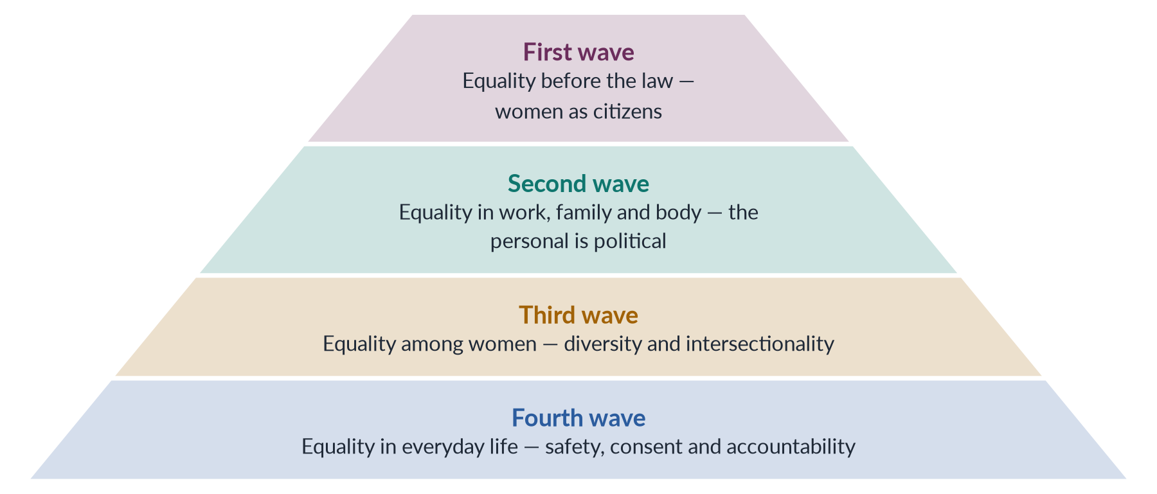
Figure 9 · How each wave deepened the meaning of equality.
Each wave kept the gains of the one before and pushed further: from the public sphere (vote, law) into the private sphere (family, body), then to differences among women, and finally to everyday experience, online and offline.

5.3 Goals — from one demand to many
- The first wave had one great goal — the vote — which united very different women.
- The second wave had several: equal pay, reproductive rights, an end to violence.
- The third wave had many, sometimes competing, goals.
- The fourth wave re-centred one issue — sexual harassment and violence — but framed it intersectionally.

5.4 Strategies — how the methods changed
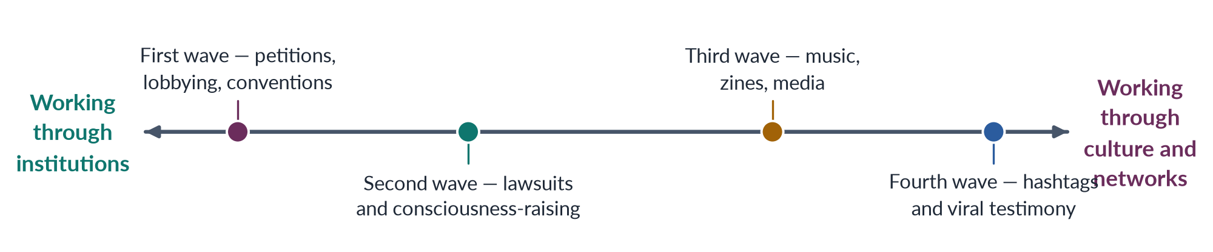
Figure 10 · The main method of each wave, from institutional to cultural and digital.
The means of communication shaped each wave: pamphlets and conventions (first); paperback books, magazines and television (second); independent music and the early internet (third); smartphones and social media (fourth).

5.4a The theory behind each wave
Each wave drew mainly on the schools taught in Topic 2:
- The first wave was liberal: Wollstonecraft and Mill argued that women are rational citizens with equal rights.
- The second wave was liberal (Friedan, NOW) and radical and socialist (Millett, Firestone, Hartmann) — the argument between "reform" and "liberation".
- The third wave was Black, postmodern, queer and postcolonial (hooks, Crenshaw, Butler, Mohanty).
- The fourth wave is intersectional and practical: it uses Crenshaw's idea as its starting point and applies it through digital testimony.

5.4b Pakistan through the lens of the waves
Table 10 · The waves as they appear in Pakistan's history.
Wave | Pakistani equivalent | Evidence
First | Welfare and reform (1947–1970) | Vote at independence; APWA (1949); MFLO (1961); girls' schools and colleges
Second | Legal resistance (1980s) | WAF (1981) against the Hudood Ordinances (1979); 12 February 1983; later laws on violence
Third | NGOs and diversity (1990s–2000s) | Beijing (1995); CEDAW (1996); NGO boom; Islamic feminism; rural and minority women
Fourth | Digital and street activism (2018–) | Aurat March; #MeToo; cyber-harassment helplines; bodily autonomy

In Pakistan the phases overlap far more than in the West: first-wave goals such as girls' schooling and inheritance are still unfinished while fourth-wave campaigns run online.

5.5 How the waves affected women's lives
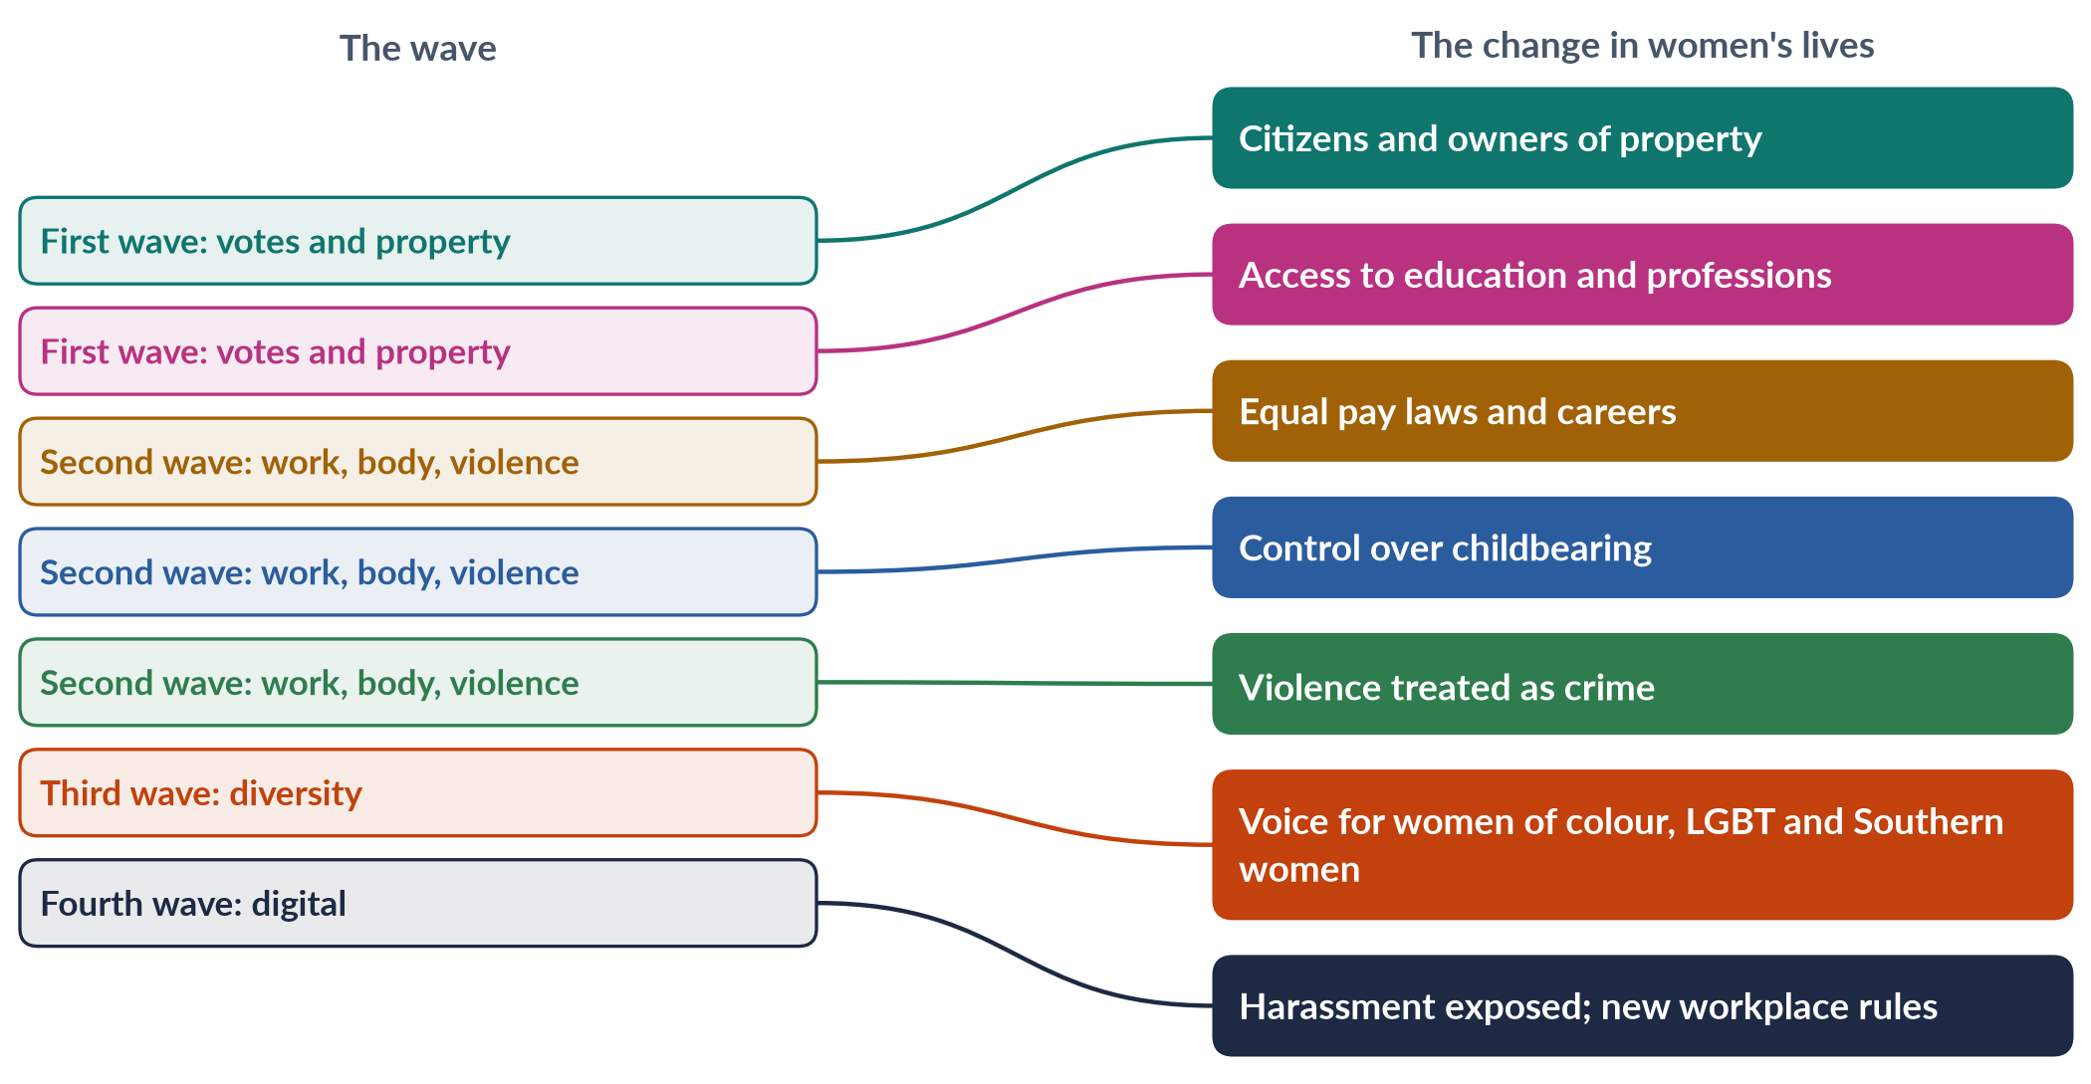
Figure 11 · What each wave changed in women's lives.
1. Political life. Women vote and stand for office almost everywhere; by the mid-2020s about a quarter of the world's parliamentarians were women.
2. Legal status. Married women own property, sign contracts and seek divorce; discrimination is unlawful in most countries.
3. Education and work. Women now outnumber men at university in many countries and work in every profession — though pay gaps and "glass ceilings" remain.
4. Health and body. Contraception and, in many countries, safe abortion give women control over childbearing.
5. Safety. Rape, domestic violence and harassment are crimes; shelters and hotlines exist.
6. Voice and identity. Diverse women speak for themselves; harassment has become costly for perpetrators.

5.5a One life across four waves
Imagine the women of one family across a century and a half.
- A great-great-grandmother born in 1850 in England could not vote, could not keep her wages after marriage, could not attend university and could lose her children in a separation.
- Her granddaughter, born in 1900, voted for the first time in 1918 or 1928, perhaps worked in a munitions factory in the First World War, and could own property.
- Her granddaughter, born in 1945, went to university, could get the contraceptive pill, was protected in law against unequal pay, and could leave a violent husband with the help of a shelter.
- Her granddaughter, born in 1990, grew up with intersectional feminism, could report harassment at work, and used social media to share her experience in 2017.
Each generation inherited the gains of the last — and discovered new problems the last had not solved.

5.6 Continuity and change
BALANCED VIEW · DID THE WAVES BREAK WITH EACH OTHER, OR CONTINUE ONE STRUGGLE?
• Change: each wave had new leaders, new issues and new methods, and sometimes criticised the last (the third wave's critique of the second).
• Continuity: the same core demand — equal dignity and freedom for women — runs through all four. Issues also cross waves: violence was raised in the first wave (temperance and divorce campaigns), and the vote is still defended today.
➜ The best answer treats the waves as stages in one long movement, each building on the last.

5.7 Unfinished business
- The global gender gap was only 69.2% closed in 2026; at the current pace, parity is 120 years away (World Economic Forum).
- Violence: about one in three women worldwide has experienced physical or sexual violence (WHO, 2021).
- Reversals: the overturning of Roe v. Wade (2022) shows that gains can be lost.
- The global South: in countries like Pakistan (143rd of 145 in 2026), the waves' gains have reached many women only partly.
EXAMINER'S EYE · THE MODEL STRUCTURE FOR 2025
1. Introduction: define a wave; the metaphor (Lear 1968) and its limits. 2–5. One heading per wave, each with principles, goals and strategies as sub-headings. 6. Comparison table. 7. Effects on women's lives — political, legal, economic, bodily, safety, voice. 8. Pakistan. 9. Unfinished business. 10. Conclusion: one long movement. Draw the pyramid or the spectrum of strategies.

Chapter 6 · The United Nations and Women
The syllabus asks for "United Nations Conferences on Women". No descriptive question has yet been set on them, but the MCQs love them: the first conference (Mexico), the fourth (Beijing), the year of the Platform for Action (1995), CEDAW (1996 for Pakistan; "an international bill of rights for women"), and Human Rights Day (10 December). This chapter gives you the whole UN story.

6.1 The foundations
- The UN Charter (1945) affirms in its preamble "the equal rights of men and women". Women delegates, including those from Latin America, fought to get these words in.
- The Commission on the Status of Women (CSW) was set up on 21 June 1946 as a body of the Economic and Social Council. It still meets every March in New York.
- The Universal Declaration of Human Rights was adopted on 10 December 1948 — the date is now Human Rights Day (MCQ 2018). It says rights belong to "everyone", without distinction of sex.
- The Convention on the Political Rights of Women (1952) and the Declaration on the Elimination of Discrimination against Women (1967) prepared the way for CEDAW.

6.2 The four World Conferences on Women
The UN declared 1975 International Women's Year and 1976–1985 the UN Decade for Women, under the theme "Equality, Development and Peace".
Table 11 · The four UN World Conferences on Women.
Conference | Year | What it did
Mexico City (First) | 1975 | The first world conference on women (MCQ 2016); adopted a World Plan of Action; launched the UN Decade for Women; led to UNIFEM and INSTRAW. Tensions between Western women (equality) and women of the South (development, peace)
Copenhagen (Second) | 1980 | Mid-Decade review; CEDAW opened for signature in a ceremony; stressed employment, health and education; found a gap between rights on paper and women's ability to use them
Nairobi (Third) | 1985 | End of the Decade; adopted the Forward-Looking Strategies to the year 2000; the NGO forum drew thousands of women, many from Africa and the South
Beijing (Fourth) | 1995 | Adopted the Beijing Declaration and Platform for Action (MCQs 2019, 2024, 2026) — 189 governments; 12 critical areas of concern; gender mainstreaming endorsed; a huge NGO forum at Huairou

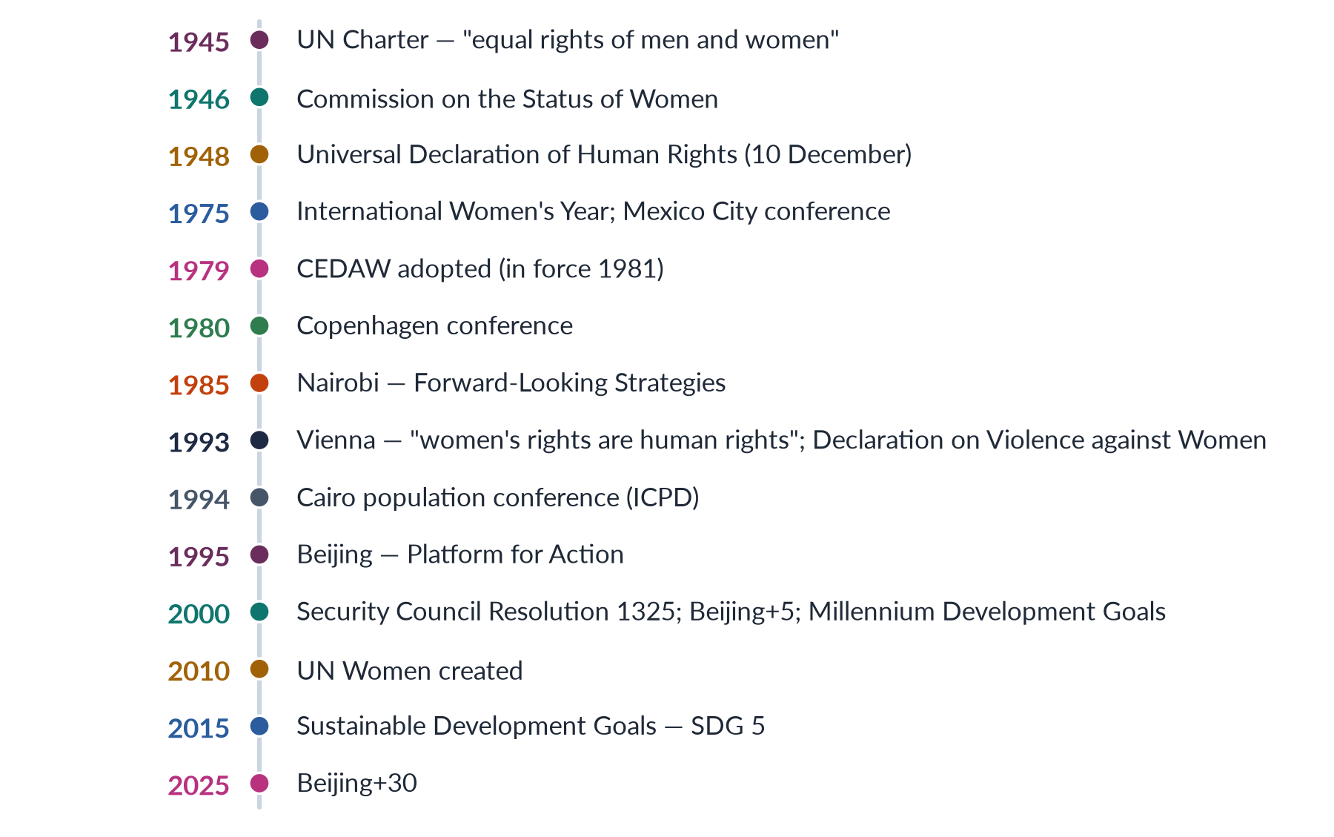
Figure 12 · The UN road for women's rights.

6.3 Beijing 1995 — the most important conference
✦ CASE
The Fourth World Conference on Women, Beijing (4–15 September 1995) · the landmark
Governments of 189 countries adopted the Beijing Declaration and Platform for Action, still the most complete global plan for women's rights. The phrase "women's rights are human rights" — used earlier at Vienna in 1993 — became the conference's message. Prime Minister Benazir Bhutto of Pakistan addressed the conference.

Table 12 · Beijing's 12 critical areas of concern.
Code | Area | Code | Area
A | Women and poverty | G | Women in power and decision-making
B | Education and training of women | H | Institutional mechanisms for the advancement of women
C | Women and health | I | Human rights of women
D | Violence against women | J | Women and the media
E | Women and armed conflict | K | Women and the environment
F | Women and the economy | L | The girl child

- Area K is why a 2023 MCQ said the Beijing conference identified women's vital role in environmental management.
- Beijing endorsed gender mainstreaming: assessing the effect on women and men of every policy, in every sector.
- The reviews: Beijing+5 (New York, 2000), +10 (2005), +15 (2010), +20 (2015), +25 (2020) and +30 (2025), reviewed at the CSW each time. The Beijing+30 review found real progress in girls' education and laws, but warned of slow change in power, persistent violence and a backlash against women's rights in many countries.

6.4 CEDAW — the international bill of rights for women
✦ LAW & POLICY
CEDAW · adopted 18 December 1979 · in force 3 September 1981
The Convention on the Elimination of All Forms of Discrimination against Women defines discrimination against women (Article 1) and requires states to end it in law, politics, education, work, health, marriage and family life. States report every four years to the CEDAW Committee of 23 experts. An Optional Protocol (1999) lets individuals complain to the Committee; Pakistan has not joined it.
➜ A 2026 MCQ: CEDAW is often described as an international bill of rights for women.

Table 13 · Key articles of CEDAW.
Article | Content
1 | Definition of discrimination against women
2 | States must condemn discrimination and change laws, customs and practices
4 | Temporary special measures (such as quotas) are not discrimination
5 | Change social and cultural patterns and stereotypes of women's inferiority
7 | Equality in political and public life
10 | Equality in education
11 | Equality in employment
12 | Equality in health care, including family planning
14 | Rural women
16 | Equality in marriage and family relations
29 | Settlement of disputes between states (the International Court of Justice)

PAKISTAN ANGLE · PAKISTAN AND CEDAW
Pakistan acceded to CEDAW on 12 March 1996 (MCQs 2016, 2018, 2019). It made a general declaration that its accession is subject to the provisions of the Constitution, and a reservation to Article 29(1) (disputes going to the International Court of Justice). Pakistan reports periodically to the CEDAW Committee, which has repeatedly urged it to repeal discriminatory laws, enforce laws against violence and child marriage, and raise women's economic and political participation.

6.4a CEDAW in Pakistani courts and policy
CEDAW is not automatically part of Pakistani law — a treaty must be implemented by legislation. But Pakistani courts have cited it when interpreting women's constitutional rights, and Parliament has referred to it when passing laws on harassment, acid attacks and violence. The National Commission on the Status of Women monitors Pakistan's compliance, and NGOs prepare "shadow reports" to the CEDAW Committee giving their own account alongside the government's.
IN SIMPLE WORDS
CEDAW works like a report card. Every few years Pakistan must explain to a UN committee what it has done for women; activists send their own version; the committee publishes its comments. It cannot punish — but it keeps the questions coming.

6.5 After Beijing: the wider UN agenda
- Vienna World Conference on Human Rights (1993) and the Declaration on the Elimination of Violence against Women (DEVAW, December 1993).
- Cairo International Conference on Population and Development (1994) — reproductive rights and men's responsibility.
- Security Council Resolution 1325 (31 October 2000) on Women, Peace and Security — women's role in preventing conflict and building peace.
- Millennium Development Goals (2000) — Goal 3: gender equality; Goal 5: maternal health.
- UN Women (created by the General Assembly in July 2010; operational from 2011; first head Michelle Bachelet) merged four earlier UN bodies, including UNIFEM.
- Sustainable Development Goals (2015) — SDG 5: "Achieve gender equality and empower all women and girls", with targets on discrimination, violence, child marriage, unpaid care, leadership and reproductive rights.
- HeForShe (2014) and the Generation Equality Forum (2021).

6.5a The NGO forums and the voices of the South
Alongside each government conference, an NGO forum gathered activists: about 6,000 at Mexico City (1975), about 14,000 at Nairobi (1985) and about 30,000 at Huairou, near Beijing (1995). At Mexico City, women from the South argued that for them development, peace and an end to colonialism and apartheid mattered as much as legal equality; Western feminists learnt that "women's issues" were not the same everywhere. By Nairobi and Beijing, networks such as DAWN (Development Alternatives with Women for a New Era, founded 1984) had made Southern women's voices central.

6.5b Criticisms of CEDAW and Beijing
1. Reservations. Many states — including several Muslim-majority states — made broad reservations to key articles (such as Article 2 or 16), which the CEDAW Committee says weaken the treaty.
2. No enforcement. The Committee can only review reports and recommend.
3. Cultural objections. Some critics call the agenda Western; defenders point out that states negotiated and adopted it themselves.
4. Implementation gaps. Beijing+30 found that no country had achieved full equality.

6.6 Assessment of the UN's role
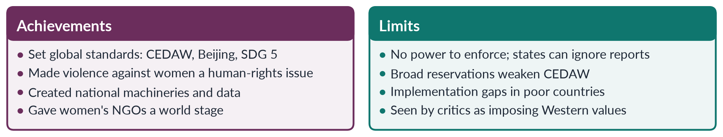
Figure 13 · The UN and women: achievements and limits.
PAKISTAN ANGLE · WHAT THE UN PROCESS GAVE PAKISTAN
The UN process shaped Pakistan's women's machinery: a Women's Division (1979), the Beijing follow-up National Plan of Action (1998), the National Commission on the Status of Women (2000), the National Policy for Development and Empowerment of Women (2002), gender-reform programmes and the reserved seats of 2002. CEDAW reporting also gives Pakistani activists a regular international platform to press the state.

Chapter 7 · Roots of the Movement in South Asia and the Pakistan Movement
Pakistan's women's movement did not begin in 1981 or in 2018. It grew from nineteenth-century social reform, from Muslim women's education, and from women's part in the Pakistan Movement itself. A 2026 MCQ asked who led the reform movement that advocated women's education and opposed sati (answer: Raja Ram Mohan Roy).

7.1 Social reform in nineteenth-century India
Reformers — mostly men at first — campaigned against customs that harmed women.
Table 14 · Nineteenth-century reforms affecting women in British India.
Year | Reform | Who and what
1829 | Bengal Sati Regulation | Raja Ram Mohan Roy's campaign against sati (widow burning); banned under Governor-General Bentinck
1856 | Hindu Widows' Remarriage Act | Ishwar Chandra Vidyasagar's campaign for widows' right to remarry
1882 | Stri Purush Tulana | Tarabai Shinde's attack on double standards
1891 | Age of Consent Act | Raised the age of consent for girls from 10 to 12
1929 | Child Marriage Restraint Act ("Sarda Act") | Set minimum marriage ages (14 for girls, later raised); still the base law in parts of Pakistan until provincial reforms
1939 | Dissolution of Muslim Marriages Act | Gave Muslim women grounds to seek divorce through the courts

7.2 Muslim women's education and reform
- Sir Syed Ahmad Khan (Aligarh, 1875) focused on Muslim men's modern education and was cautious about girls' schooling; others pushed further.
- Deputy Nazir Ahmad's novel Mirat-ul-Uroos (1869) promoted girls' education within the home.
- Sayyid Mumtaz Ali published Huquq-un-Niswan (1898) in Lahore, arguing from the Qur'an for women's rights; with his wife Muhammadi Begum he ran the women's journal Tahzib-e-Niswan (from 1898).
- Sheikh Abdullah ("Papa Mian") and Wahid Jahan Begum founded a girls' school at Aligarh in 1906, later Aligarh Women's College.
- Begum Rokeya Sakhawat Hossain wrote Sultana's Dream (1905) and founded a girls' school in Calcutta (1911).
- Sultan Jahan Begum, ruler of Bhopal, supported Muslim women's education and associations.
- The All-India Muslim Ladies' Conference (Anjuman-e-Khawateen-e-Islam), from 1914, called for education and spoke against polygamy and purdah abuses.
- The Shariat Application Act of 1937 applied Islamic personal law to Indian Muslims; women activists supported it partly because it gave women inheritance rights that custom denied.
IN SIMPLE WORDS
Early Muslim reformers wanted women to be educated as good Muslim wives and mothers. This "reform within tradition" shaped Pakistani feminism: it often argues from Islam and asks for education, inheritance and family-law rights first.

7.3 Women in the Pakistan Movement
- The All-India Muslim League formed a Central Women's Sub-Committee at its Patna session in 1938, to bring women into the movement.
- Fatima Jinnah, the Quaid's sister, travelled with him and became the symbol of Muslim women's political role — later called Madar-e-Millat ("Mother of the Nation").
- Begum Jahanara Shahnawaz and Begum Shaista Suhrawardy Ikramullah became the first two women members of Pakistan's Constituent Assembly (1947).
- Begum Ra'ana Liaquat Ali Khan organised women's volunteer services.
- During the civil disobedience campaign in Punjab in February 1947, a teenage student, Fatima Sughra, replaced the Union Jack with the Muslim League flag on the Punjab Civil Secretariat in Lahore.
- Women organised processions, relief work and picketing, and many were arrested.
✦ QUOTATION
Quaid-e-Azam Muhammad Ali Jinnah · Aligarh, 10 March 1944
"No nation can rise to the height of glory unless your women are side by side with you. We are victims of evil customs. It is a crime against humanity that our women are shut up within the four walls of the houses as prisoners."
➜ The line most quoted by Pakistani feminists of every school.

7.3a Women leaders of the Pakistan Movement
Table 15 · Women of the Pakistan Movement you should be able to name.
Leader | Role
Fatima Jinnah (1893–1967) | Dentist; the Quaid's constant companion; led women's work in the Muslim League; Madar-e-Millat; presidential candidate in 1965
Begum Jahanara Shahnawaz (1896–1979) | The only Muslim woman delegate at the Round Table Conferences (1930–32); member of the first Constituent Assembly
Begum Shaista Ikramullah (1915–2000) | First Muslim woman to earn a PhD from the University of London; member of the first Constituent Assembly; later a diplomat
Begum Ra'ana Liaquat Ali Khan (1905–1990) | Economist; organised women volunteers; founded APWA (1949); later Governor of Sindh
Lady Abdullah Haroon | Led women's Muslim League work in Sindh
Begum Salma Tassaduq Hussain | Led the Punjab women's Muslim League; arrested during the 1947 civil disobedience
Begum Viqar-un-Nisa Noon (1920–2000) | Muslim League worker in the 1947 Punjab agitation; later active in social welfare
Fatima Sughra (1931–2017) | As a teenager replaced the Union Jack with the Muslim League flag on the Punjab Civil Secretariat (1947)

These women came mostly from educated, prominent families. Their activism was framed as service to the nation and the Muslim community, which made it respectable — and set the tone for APWA's welfare approach after 1947.

7.4 Partition and the refugee crisis (1947)
Partition was the first great test. Millions of refugees crossed the new borders; tens of thousands of women were abducted, raped or killed on both sides. Women volunteers, led by Begum Ra'ana Liaquat Ali Khan, ran camps, hospitals and recovery work. The Women's Voluntary Service and the Women's National Guard grew out of this effort, and in 1949 they led to APWA (Chapter 8).
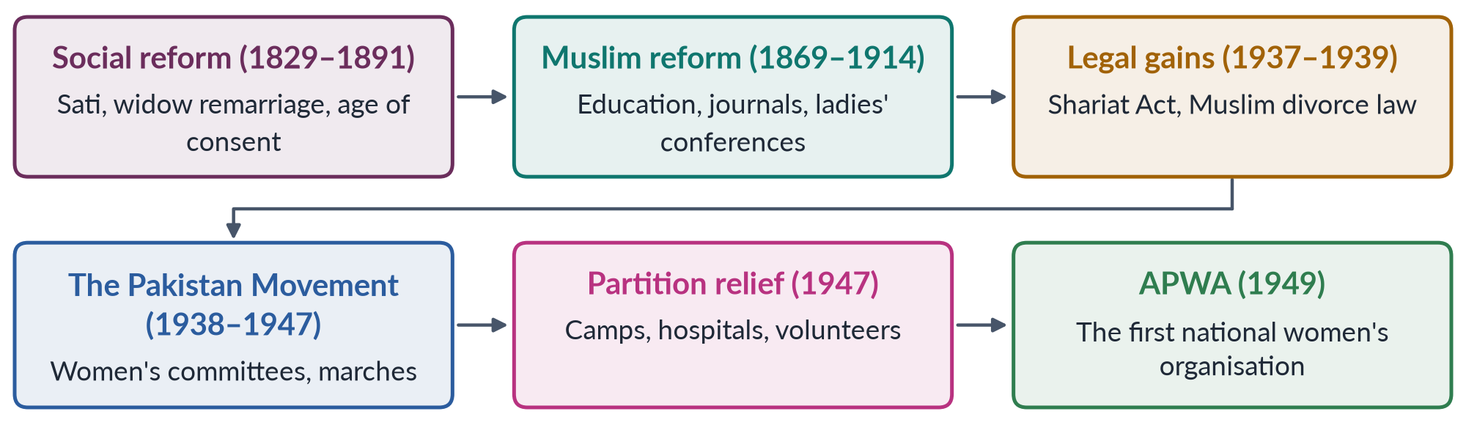
Figure 14 · From reform to movement: the roots of Pakistan's women's movement.

7.4a The first test after independence: women's inheritance (1948)
One of the first campaigns in the new state was for women's right to inherit agricultural land. Customary law in Punjab often denied daughters and widows their Islamic share. Women legislators, including Begum Jahanara Shahnawaz and Begum Salma Tassaduq Hussain, pressed for the West Punjab Muslim Personal Law (Shariat) Application Act 1948, and women demonstrated outside the Punjab Assembly in its support. The Act applied Islamic inheritance rules, including to agricultural land. It showed a pattern that would recur: women's rights won by appealing to Islam against custom.

7.5 What the roots explain
1. Reform from within Islam. From Mumtaz Ali to today's Islamic feminists, many Pakistani activists argue for women's rights in Islamic terms.
2. Education first. Girls' schooling has been the most accepted demand since the nineteenth century.
3. Elite leadership. The early movement was led by educated women of prominent families — a pattern that continued into APWA and WAF.
4. Nationalism. Women's rights were tied to building the nation, which gave them legitimacy but also made them depend on the state's goodwill.
5. The vote came with independence. Unlike the West, Pakistani women did not need a first-wave suffrage campaign; universal adult franchise came with the new state.
PAKISTAN ANGLE · WHY THIS CHAPTER MATTERS IN THE EXAM
When you "trace the evolution" of the movement (2022, 2026) or answer the "Western import" objection (2019, 2023, 2024), start here. Pakistan's movement has local roots older than the second wave: social reform, Muslim reformist writing, and women's role in creating the country.

Chapter 8 · The Women's Movement in Pakistan, Phase by Phase
This is the heart of the topic. It answers "Write a note on the women's movement in Pakistan" (2016), "Discuss in detail feminist movements in Pakistan" (2022), "APWA and WAF" (short note, 2018) and the first half of 2024 and 2026. Pakistani scholars Khawar Mumtaz and Farida Shaheed wrote the standard history, Women of Pakistan: Two Steps Forward, One Step Back? (1987).

8.1 The phases at a glance
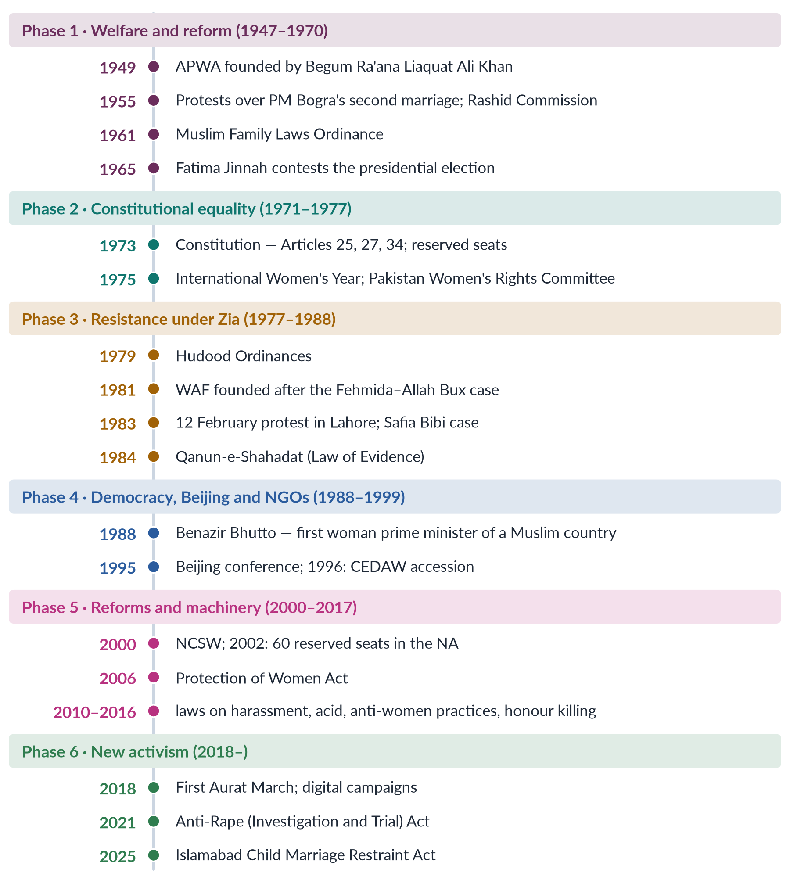
Figure 15 · The women's movement in Pakistan: six phases.

8.2 Phase 1 · Welfare and reform (1947–1970)
✦ DEFINITION
APWA · the All Pakistan Women's Association
Founded in 1949 by Begum Ra'ana Liaquat Ali Khan (its first president), wife of the first prime minister. It grew from Partition relief work into a national, non-political welfare organisation: schools, colleges, vocational centres, health clinics and handicraft industries for women.
➜ MCQs 2016, 2018 and 2019 asked its founder, first president and year.

- Family law. In 1955 Prime Minister Muhammad Ali Bogra took a second wife. APWA and other women protested; the government set up the Rashid Commission on Marriage and Family Laws (report 1956). Its recommendations led to the Muslim Family Laws Ordinance 1961 under Ayub Khan: registration of marriages, the arbitration council's permission for a second marriage, notice procedure for divorce, and the right of orphaned grandchildren to inherit.
- Politics. The 1956 Constitution reserved seats for women. In 1965 Fatima Jinnah challenged Ayub Khan for the presidency; some religious scholars supported a woman candidate in the circumstances. She lost amid claims of rigging.
- Character of the phase: elite-led, welfare-oriented, cooperative with the state — the pattern Mumtaz and Shaheed call working "within" the system.

8.3 Phase 2 · Constitutional equality (1971–1977)
- The 1973 Constitution promised equality: Article 25 (no discrimination on the basis of sex), Article 27 (public service), Article 32 (women in local government), Article 34 (full participation of women), Article 35 (protection of the family).
- Women were appointed to high offices: Begum Ra'ana Liaquat Ali Khan became Governor of Sindh (1973); women entered the foreign service and other cadres.
- International Women's Year (1975): Pakistan set up a Women's Rights Committee.

8.4 Phase 3 · Resistance under Zia-ul-Haq (1977–1988)
General Zia-ul-Haq's "Islamisation" brought laws that many women saw as discriminatory.
✦ LAW & POLICY
Hudood Ordinances · February 1979
Five ordinances on zina (adultery and rape), theft, drinking, and false accusation. Under the Zina Ordinance, a woman who alleged rape but could not prove it with the strict evidence required could herself be charged with zina — having confessed to intercourse. Thousands of women were imprisoned.
➜ MCQs 2016 and 2019: enacted in 1979 under Zia-ul-Haq. MCQ 2025: the Hudood Ordinances were a major focus of the 1980s women's movement.

✦ DEFINITION
WAF · the Women's Action Forum
Founded in Karachi in September 1981, soon with chapters in Lahore, Islamabad and Peshawar, after a court sentenced Fehmida and Allah Bux to death by stoning for zina (they had married against her family's wishes). A non-hierarchical, non-party, secular platform of women's organisations and individuals, WAF challenged the Hudood laws, the proposed Law of Evidence, separate women's universities and restrictions on women in sport and media.

✦ CASE
12 February 1983, Lahore · the defining protest
Members of WAF and the Punjab Women Lawyers' Association marched to the Lahore High Court against the proposed Law of Evidence, under which two women's testimony would equal one man's in some cases. Police baton-charged and tear-gassed them; many were arrested. The poet Habib Jalib joined them. Since 2012 Pakistan has marked 12 February as National Women's Day.

- The Safia Bibi case (1983): a young, visually impaired woman who became pregnant after rape was convicted of zina, while the accused were acquitted. Public outcry led the Federal Shariat Court to overturn the conviction.
- The Qanun-e-Shahadat Order 1984 (Law of Evidence) was enacted, with Article 17 requiring two women witnesses in financial agreements.
- Qisas and Diyat laws (1990, made permanent in 1997) later allowed families to "forgive" killers — a loophole in honour killings.
- Pakistan Commission on the Status of Women (1983–85) under Zari Sarfaraz recommended reforms; its report was shelved.
- Rural women joined the Sindhiani Tehreek (from 1982) against military rule.
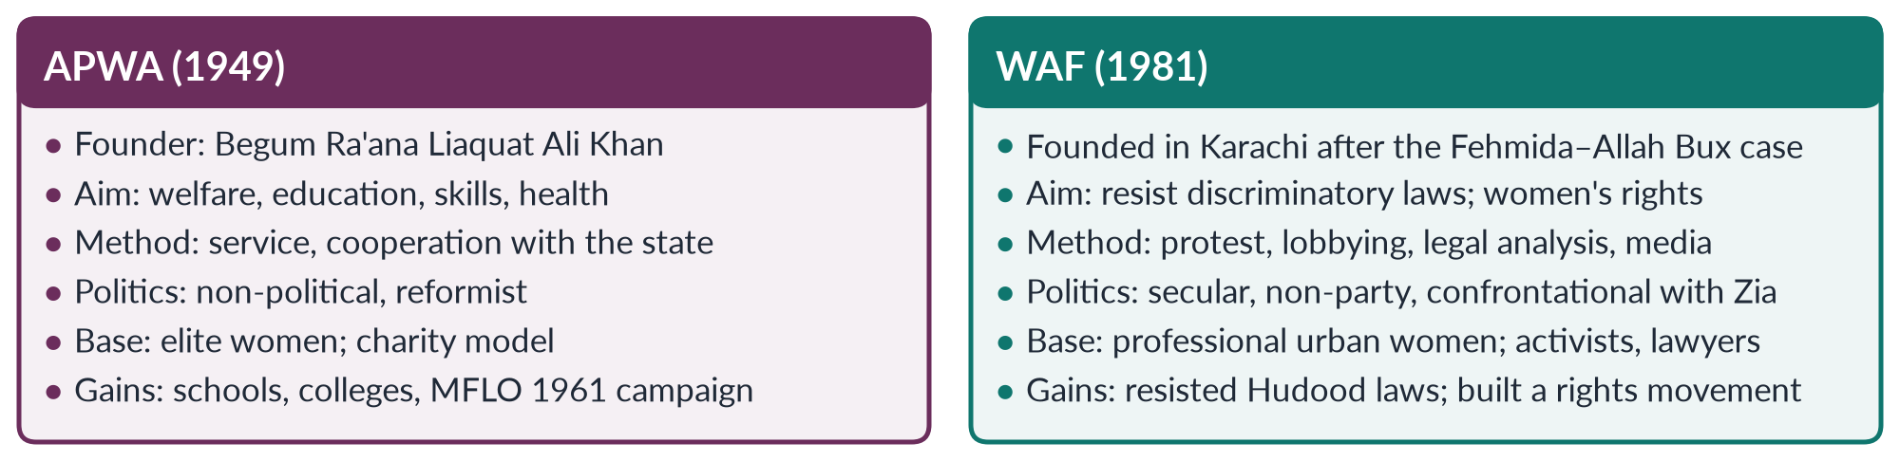
Figure 16 · APWA and WAF — the short note of 2018.

8.5 Phase 4 · Democracy, Beijing and NGOs (1988–1999)
- Benazir Bhutto became the first woman prime minister of a Muslim-majority country (1988). Her governments created the First Women Bank (1989) and women's police stations (1994), and launched the Lady Health Worker Programme (1994); but the Hudood laws were not repealed.
- Pakistan took part in Beijing (1995) and acceded to CEDAW (1996).
- NGOs multiplied — Shirkat Gah (1975), Aurat Foundation (1986), Simorgh, and many donor-funded groups — doing research, legal aid and advocacy (Chapter 10).
- The HRCP (1987) documented violence against women; the killing of Samia Sarwar in her lawyer's office (Lahore, 1999) brought honour killing to national attention.

8.6 Phase 5 · Reforms and machinery (2000–2017)
Table 16 · Laws and institutions of Phase 5.
Year | Law or institution
2000 | National Commission on the Status of Women (NCSW)
2000–01 | Devolution plan: 33% seats for women in local government
2002 | 60 reserved women's seats in the National Assembly and 17 in the Senate; National Policy for Development and Empowerment of Women
2004 | Criminal Law (Amendment) Act — first law naming "honour" crimes
2006 | Protection of Women (Criminal Laws Amendment) Act — moved rape from the Zina Ordinance to the Penal Code
2008 | Women's Parliamentary Caucus; Fahmida Mirza first woman Speaker; Benazir Income Support Programme
2010 | Protection against Harassment of Women at the Workplace Act
2011 | Acid Control and Acid Crime Prevention Act; Prevention of Anti-Women Practices Act
2016 | Anti-honour-killing amendment (October) and anti-rape amendment; Punjab Protection of Women against Violence Act
2017 | Elections Act — 5% of general-seat tickets for women; election void if women's turnout below 10% in a constituency

This phase shows state feminism: women's organisations, women legislators and commissions working through Parliament. The killing of social-media star Qandeel Baloch by her brother (July 2016) spurred Parliament to close the "forgiveness" loophole in honour killings.

8.7 Phase 6 · New activism (2018 onwards)
- The Aurat March (from 8 March 2018, first in Karachi, then Lahore, Islamabad and other cities) — young, urban, organised online; demands on violence, harassment, workers' rights, khawaja sira rights and bodily autonomy.
- The Women Democratic Front (2018) and Hum Auratein link feminism with labour and left politics.
- Digital activism and #MeToo (Chapter 4).
- New laws: Anti-Rape (Investigation and Trial) Act 2021; Enforcement of Women's Property Rights Act 2020; Islamabad Child Marriage Restraint Act 2025 (age 18); Islamabad Domestic Violence Act 2025.
- Backlash: legal petitions to ban the march, counter-marches ("Haya March"), online abuse.

8.8 The other actors: beyond APWA, WAF and the Aurat March
The movement was never only a few urban organisations. Five other groups of actors shaped it.

(1) Rural and working women
- Sindhiani Tehreek (from 1982), linked to the Awami Tehreek, organised thousands of rural Sindhi women against military rule, feudal power and for education — one of the few mass rural women's movements in South Asia.
- In the Okara military farms dispute (from 2000), women tenants defended their land rights, forming groups that confronted police and paramilitary forces.
- The Lady Health Workers, organised as a union, protested in Islamabad for regular jobs and pay; the Supreme Court ordered their regularisation in 2012.
- Home-based workers' unions won the Sindh Home-Based Workers Act 2018; women of fishing communities organised through the Pakistan Fisherfolk Forum.

(2) Religious women's organisations
- The women's wing of the Jamaat-e-Islami has long organised women for education, welfare and politics within an Islamist framework, and has opposed parts of the secular feminist agenda.
- Al-Huda (founded 1994 by Farhat Hashmi) runs Qur'an courses that reached large numbers of urban middle-class women. Scholars debate whether such piety movements empower women (by giving them religious knowledge and public roles) or reinforce conservative norms.

(3) Artists, writers and performers
- Poets Kishwar Naheed ("We Sinful Women") and Fahmida Riaz challenged the 1980s restrictions in verse.
- The theatre group Tehrik-e-Niswan (founded 1979 by Sheema Kermani) and Ajoka (founded 1984 by Madeeha Gauhar) staged plays on women's rights.
- Filmmaker Sharmeen Obaid-Chinoy won Oscars for Saving Face (2012, acid attacks) and A Girl in the River (2016, honour killing); the second is credited with adding pressure for the honour-killing law of 2016.

(4) Lawyers and human-rights defenders
Asma Jahangir and Hina Jilani, with colleagues, founded the first all-women law firm (1980) and AGHS Legal Aid; Asma Jahangir co-founded the Human Rights Commission of Pakistan (1987) and defended women in Hudood cases. Women lawyers turned protest into litigation and legislation.

(5) Women in Parliament and the state
Women legislators — especially after the 2002 reserved seats — formed the cross-party Women's Parliamentary Caucus (2008) and moved many of the laws of 2010–2016. Commissions (NCSW, provincial commissions) and ombudspersons became allies inside the state.
IN SIMPLE WORDS
Pakistan's women's movement is a network: elite welfare workers, secular activists, rural peasants, health workers, religious women, poets, lawyers and legislators. They often disagree — but most major gains came when several of them pushed at once.

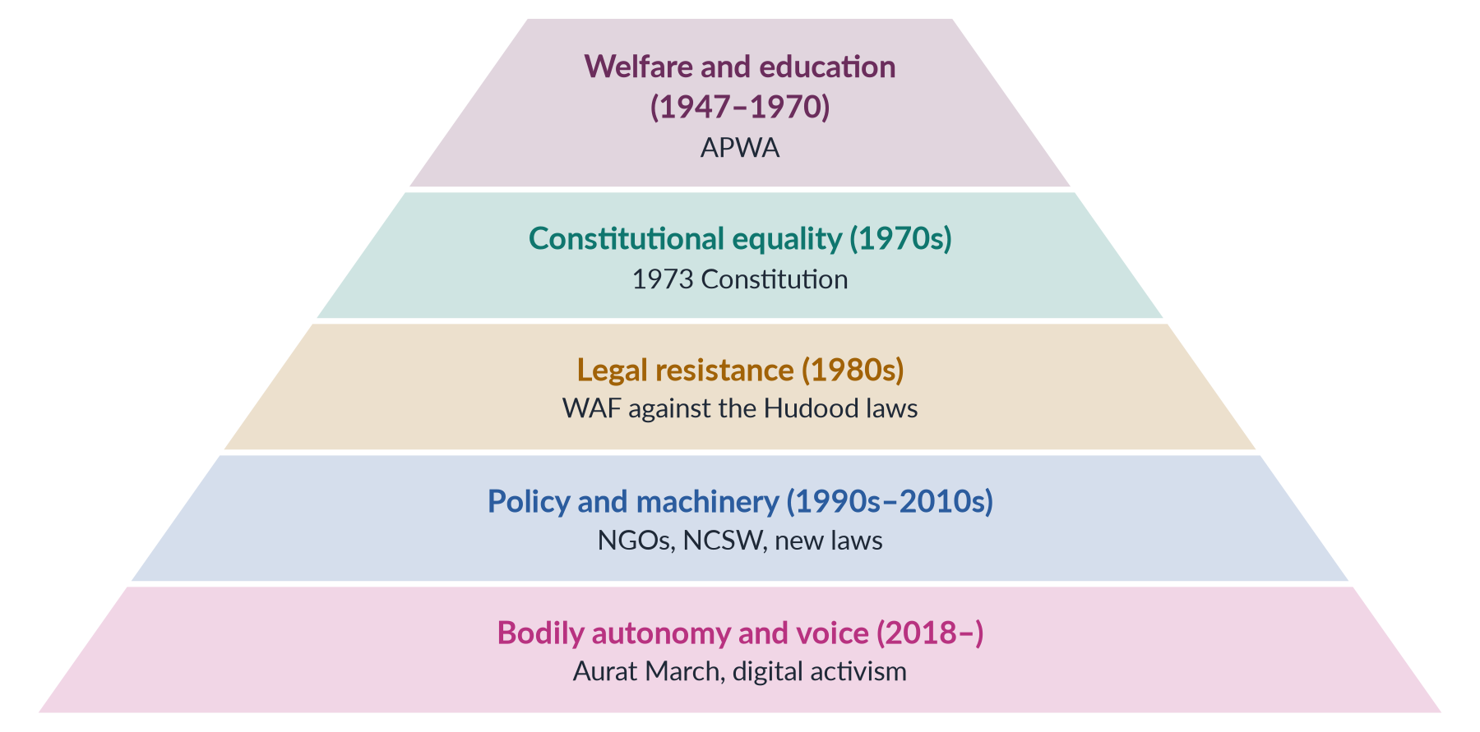
Figure 17 · How the focus of Pakistan's movement has shifted over time.
EXAMINER'S EYE · ANSWERING "DISCUSS IN DETAIL FEMINIST MOVEMENTS IN PAKISTAN" (2022)
Give a definition and the Mumtaz–Shaheed history in the introduction; then one heading per phase (six), each with dates, organisations, leaders, laws and a line of evaluation; then a heading on actors (APWA, WAF, NGOs, rural movements, the state, the Aurat March); then strengths, weaknesses and the way forward (Chapter 11). Draw the timeline or the pyramid.

Chapter 9 · The Western Waves and Pakistan: Influence, Past and Emerging Trends
The examiner keeps asking for the link. 2019 and 2023 (an exact repeat): "Discuss the influence of these waves on feminist movements in Pakistan." 2024: "Write in detail the impact of Western feminist movements on the feminist movement in Pakistan. Compare Pakistani feminist movements of the past with emerging trends." 2026: "How has the locus of resistance shifted from 'legal rights' to 'bodily autonomy'?" This chapter answers all three.

9.1 How ideas travelled
Western feminist ideas reached Pakistan through five channels:
1. Education — women educated in Britain and the USA, and university courses (Women's Studies centres, 1989).
2. The United Nations — the conferences (Mexico 1975 to Beijing 1995), CEDAW (1996) and SDG 5.
3. Donors and NGOs — funding for projects on gender, rights and development (Chapter 10).
4. Media — books, magazines, satellite television and, since the 2010s, social media.
5. Diaspora scholars — such as Riffat Hassan and Asma Barlas, who carried debates both ways.

9.2 Wave by wave: what Pakistan took
Table 17 · The influence of each Western wave on Pakistan.
Wave | What Pakistan took | How it was adapted
First | Education, property, legal status, the vote | Vote came with independence (1947); APWA's schools; MFLO 1961 argued in Islamic terms
Second | "Personal is political"; violence, body, sexuality; legal activism | WAF against Hudood (1981); focus on law rather than sexuality; later laws on harassment (2010) and honour (2016)
Third | Diversity; intersectionality; NGOs; global human rights | Beijing (1995), CEDAW (1996); NGO boom; attention to rural and minority women; Islamic feminism
Fourth | Digital activism; #MeToo; bodily autonomy | Aurat March (2018); online campaigns; cyber-harassment helplines; strong backlash

9.3 Not a copy: why Pakistan's path differs
BALANCED VIEW · DID THE WEST SHAPE PAKISTAN'S MOVEMENT?
• Yes, strongly. Many terms, methods and funds came from the West and the UN: consciousness-raising, legal advocacy, gender mainstreaming, hashtags. WAF's leaders were often Western-educated.
• But not simply. (1) Pakistan's movement has local roots (Chapter 7). (2) The waves arrived out of order and together — first-wave issues (education, property) remain live alongside fourth-wave ones. (3) Pakistani feminists adapted ideas to Islam and local culture, and faced a state that used religion to restrict women (Zia). (4) The postcolonial critique (Mohanty, Spivak) was itself a Southern answer to Western feminism.
➜ The best view: the West supplied tools and platforms; Pakistani women chose, adapted and sometimes rejected them in their own struggles.

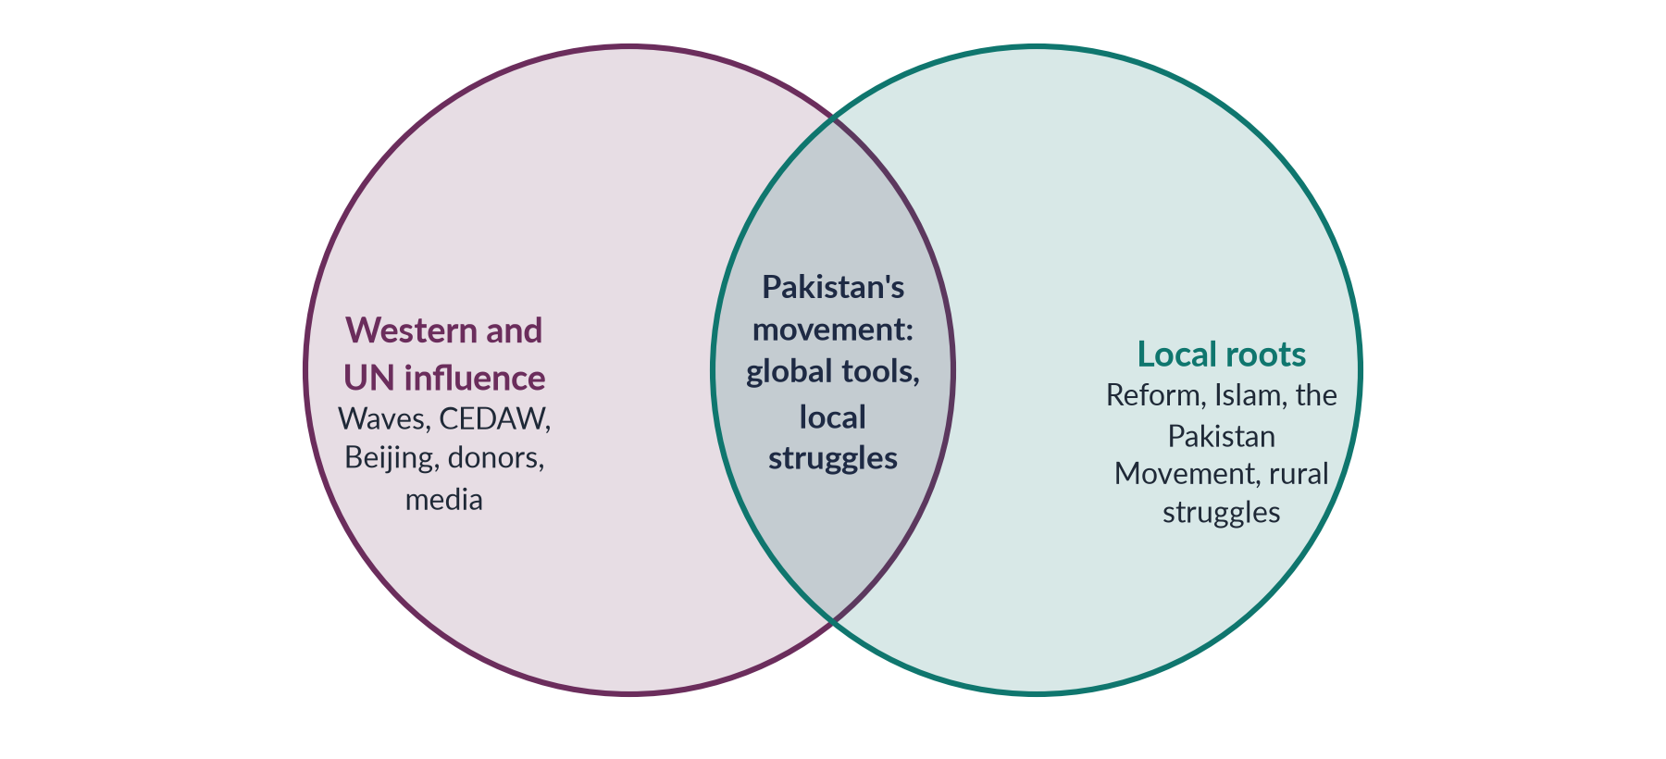
Figure 18 · Western influence and local roots in Pakistan's women's movement.

9.3a Two case studies of adaptation
Case 1 — the Hudood debate (1980s). WAF's campaign against the Hudood Ordinances used second-wave ideas — that the state was controlling women's bodies and punishing victims — but argued them largely in legal and Islamic terms: that the laws misread Islamic principles of justice, and violated Articles 25 and 34 of the Constitution. Religious scholars were invited to debate interpretation. The campaign was second-wave in content and Pakistani in form.
Case 2 — the Aurat March (2018–). The march uses fourth-wave tools — hashtags, placards designed for social media, testimony — but its demands are also local: inheritance, forced marriage, the rights of home-based and domestic workers, the protection of khawaja siras, and an end to honour killings. Its slogans were written in Urdu and regional languages, and its organisers include workers' and students' groups.
IN SIMPLE WORDS
Pakistan borrows the tools of each wave, but fits them to its own problems — Hudood laws in the 1980s, honour killings and harassment today.

9.4 Past versus emerging trends (2024)
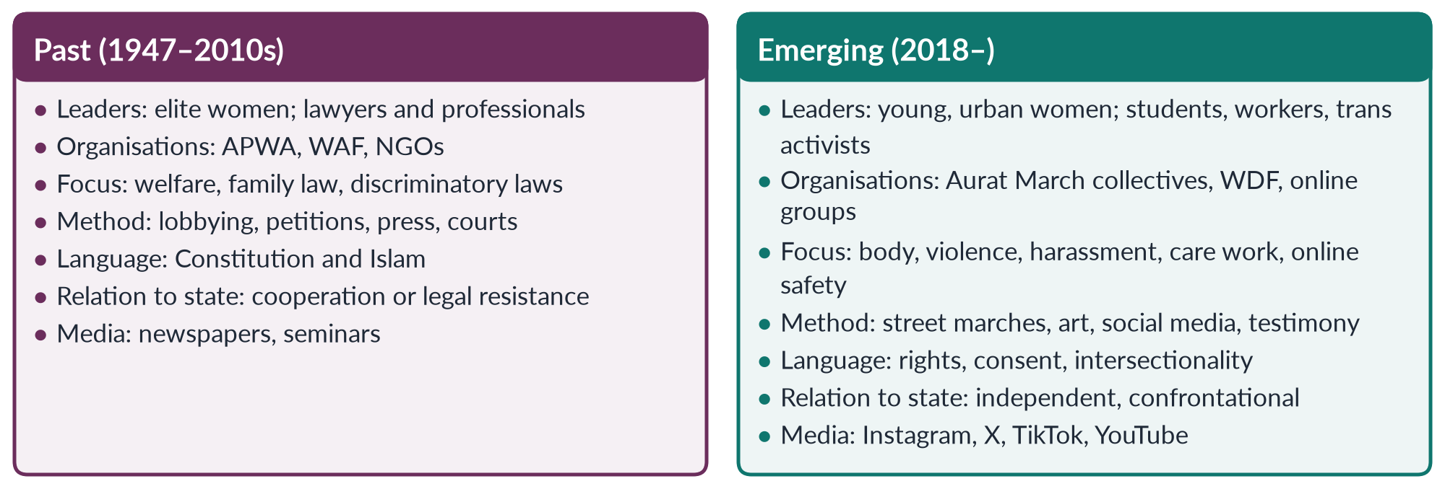
Figure 19 · Pakistan's feminist movement: past and emerging.
Effects of the emerging trends.
1. Visibility — women's issues on prime-time television every March.
2. Inclusion — khawaja siras, working-class women, religious minorities and women with disabilities speak on the same stage.
3. Faster response — online outrage pushes the state to act (the 2020 motorway case led to the Anti-Rape law of 2021).
4. Backlash and polarisation — court petitions, counter-marches, online abuse and threats; slogans used to discredit the movement.
5. Class limits — the digital divide means rural women are still less represented.

9.4b Why "bodily autonomy" provokes such strong reactions
In Pakistan, a woman's body is often seen as carrying the honour (izzat) of her family. Claims that a woman alone decides about her body therefore sound, to critics, like a rejection of family and religion — even when activists mean freedom from violence, forced marriage and harassment. Supporters answer that Islam itself forbids forced marriage and protects the dignity of every person, and that the Constitution guarantees the "dignity of man" (Article 14). The quarrel over words has sometimes hidden a wide agreement on substance: few Pakistanis defend acid attacks, honour killings or child marriage.

9.4a Western influence on specific Pakistani laws
Table 18 · Where international and Western influence can be traced in Pakistani law.
Pakistani law or policy | International or Western source | Local adaptation
Workplace Harassment Act 2010 | Second-wave idea of harassment as discrimination; CEDAW Article 11 | Code of conduct and inquiry committees; ombudsperson
Reserved seats 2002; 33% local seats 2001 | CEDAW Article 4 (special measures); Beijing area G | Indirect election through party lists
NCSW 2000; Women's Division | Beijing area H (national machinery) | Statutory commission, later strengthened in 2012
Honour-killing law 2016 | Global campaigns on violence against women | Removed the "forgiveness" route; framed in Islamic and constitutional terms
Child Marriage Restraint Act (ICT) 2025 | SDG target 5.3; CEDAW Article 16 | Age 18 for both sexes; opposed by the Council of Islamic Ideology

9.5 From "legal rights" to "bodily autonomy" (2026)
✦ DEFINITION
Locus of resistance · the 2026 phrase
The place or focus where a movement concentrates its struggle. The 2026 question argues that Pakistan's movement moved from fighting laws (the 1980s) to claiming control over women's own bodies (the 2020s).

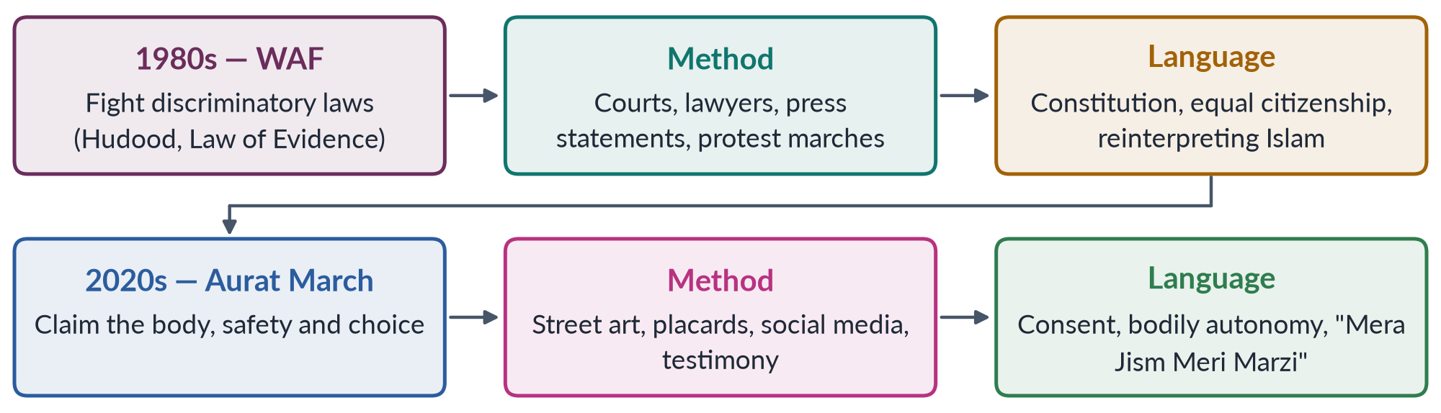
Figure 20 · The shift in the locus of resistance.
Why the shift happened.
1. Many legal battles were won. The 2006 Act moved rape out of the Zina Ordinance; laws on harassment, acid, honour and rape followed. Activists found that laws exist but violence continues — the problem moved from the statute book to the home, street and screen.
2. A new generation. Young women raised on the internet framed problems as personal experience.
3. Global fourth-wave influence — #MeToo and consent campaigns.
4. The body as the site of control. Honour killings, forced marriage, harassment and marital rape are all about control of women's bodies.
Continuity. The shift is not total. The Aurat March still demands laws (on domestic violence, workplace harassment, child marriage), and WAF in the 1980s was already defending women's bodies against flogging and stoning. The better formula: from rights on paper to rights over one's own body.
EXAMINER'S EYE · LINKING THE WAVES TO PAKISTAN
For 2019/2023 and 2024, never write the Western history and then add one paragraph on Pakistan. After each wave, add a sub-heading "In Pakistan" with a date, organisation and law. Then end with a balanced judgement: influence, adaptation and local roots.

Chapter 10 · NGO-isation of the Women's Movement
The 2026 question asked candidates to "critically examine the 'NGO-ization' of the women's movement in Pakistan. Has the donor-driven agenda of gender mainstreaming depoliticized the feminist struggle, converting it into a technocratic 'project' rather than a social revolution? Use the WAD (Women and Development) critique." This chapter teaches every word of that question.

10.1 The words
✦ DEFINITION
NGO-isation · also spelt NGO-ization
The process by which a social movement's energy moves into professional, formally registered, donor-funded non-governmental organisations. Activists become paid staff; campaigns become projects with budgets, targets and reports; accountability runs upwards to donors rather than outwards to members.
➜ The term was developed by scholars such as Sonia Alvarez (on Latin America, 1999) and Islah Jad (on the Arab world, 2004).

✦ DEFINITION
Depoliticisation · the central charge
Turning a struggle about power — who rules, who owns, who decides — into a technical problem to be managed by experts, training workshops and indicators. The question calls this a "technocratic 'project'" instead of a "social revolution".

✦ DEFINITION
WAD — Women and Development · the lens the question asks for
A 1970s critique, drawing on Marxist and dependency theory, of the earlier WID (Women in Development) approach. WID said women were "left out" of development and should be integrated into it. WAD replied that women have always been part of development — but on unequal terms, exploited by global capitalism and class structures. Adding women to projects does not change the system that exploits them.
➜ Topic 4 teaches WID, WAD and GAD in full. Here, WAD is the tool for judging NGOs.

10.2 How NGO-isation happened in Pakistan
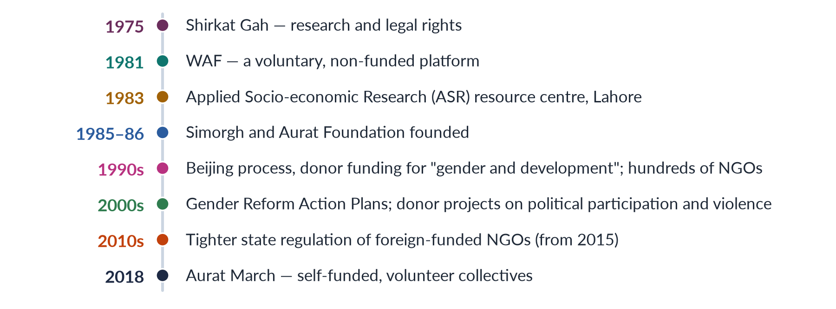
Figure 21 · The rise of women's NGOs in Pakistan.
- Why it happened: military rule closed political space in the 1980s; donors after Beijing (1995) funded "gender" projects; NGOs offered jobs, resources and some protection; the state welcomed service delivery.
- What NGOs did well: research on women's lives; legal aid and shelters; training of women councillors after 2001; drafting and lobbying for laws (harassment 2010, acid 2011, honour 2016); data on violence.

10.3 The case that NGO-isation depoliticised the movement
1. Donor-driven agendas. Priorities follow funding cycles and donor fashions (micro-credit, then governance, then violence) rather than members' needs.
2. Projectisation. Three-year projects with log-frames and "deliverables" cannot sustain long struggles against feudal, patriarchal or state power.
3. Professionalisation. Paid experts replace volunteers; activism becomes a career; English-language reports replace mass mobilisation.
4. Upward accountability. NGOs answer to donors, not to the women they serve.
5. Class and urban bias. Offices in Islamabad, Lahore and Karachi; rural and working-class women become "beneficiaries", not leaders.
6. Legitimacy cost. Foreign funding lets critics call feminism a "Western agenda".
7. Competition and fragmentation. NGOs compete for grants instead of building one movement.
8. The WAD critique. Projects that add women to income-generation or training leave untouched the class structures and global economy that exploit women's labour — they integrate women into an unequal system rather than change it.
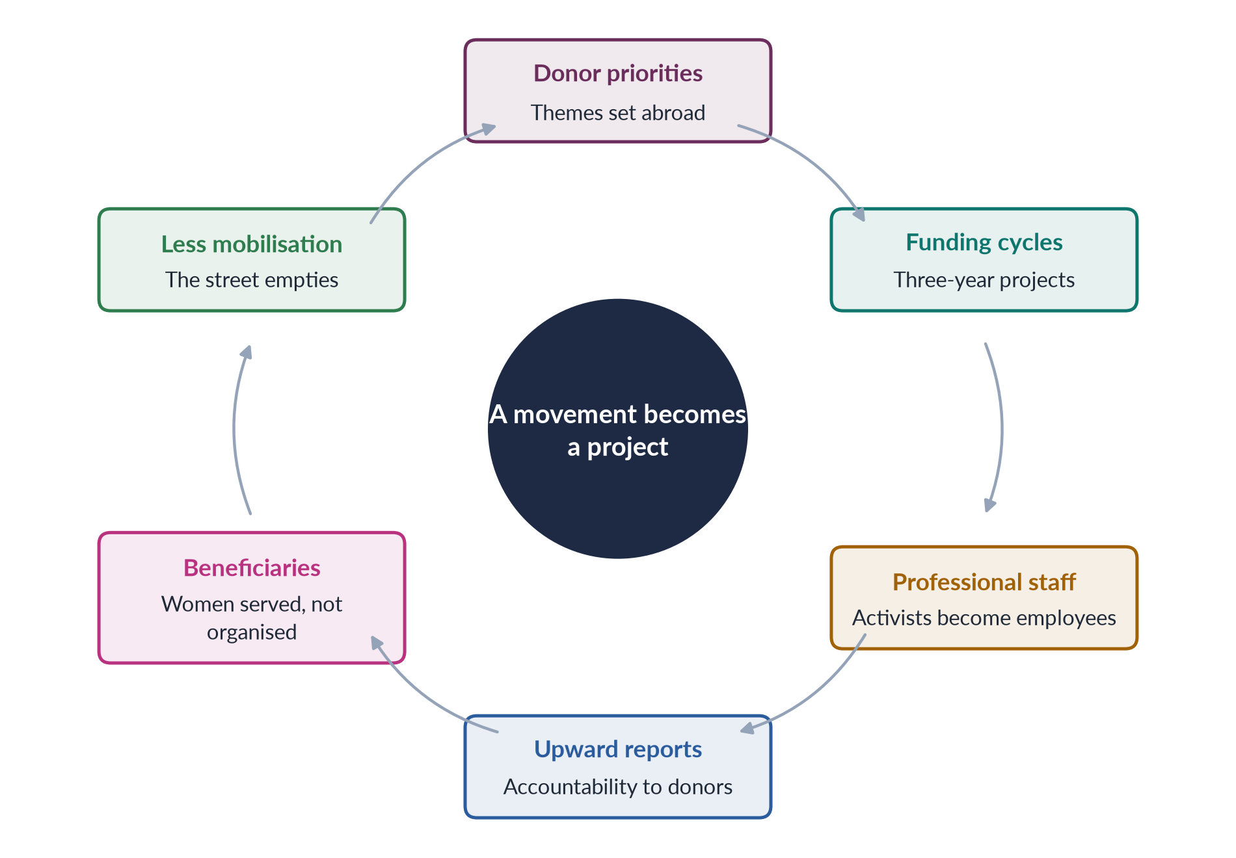
Figure 22 · The NGO-isation cycle, as its critics describe it.

10.4 The case against (or for a balanced view)
1. NGOs won laws. Much of Pakistan's pro-women legislation since 2000 was researched, drafted and lobbied by NGOs and women legislators working together.
2. They kept space open under military rule and in areas where political parties ignored women.
3. Services save lives — shelters, legal aid and helplines are not "depoliticised" to the woman who uses them.
4. Not all NGOs are alike. WAF refused to become a funded NGO; many groups combine services with advocacy.
5. Movements revive. The self-funded Aurat March (2018) shows that NGO-isation did not end grassroots feminism.
6. Local funding and ownership are growing, and state regulation since 2015 has reduced dependence on foreign donors.
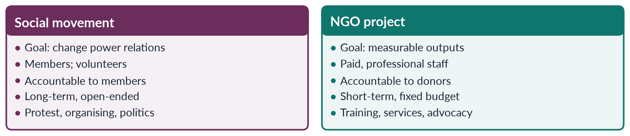
Figure 23 · A social movement and an NGO project.

10.4a WID, WAD and GAD — the three lenses
Table 19 · Three approaches to women and development (full detail in Topic 4).
Aspect | WID (1970s) | WAD (late 1970s) | GAD (1980s–)
Problem | Women left out of development | Women included on unequal, exploitative terms | Unequal power relations between women and men
Solution | Integrate women: projects, credit, training | Change the global and class structures | Empower women; transform gender relations
Roots | Liberal feminism; Boserup (1970) | Marxist and dependency theory | Socialist feminism; Moser, Kabeer
Critique of NGOs | — | NGO projects "add women" without changing structures | NGOs must support women's own organising

Applying WAD to Pakistan. Micro-credit and handicraft projects for women brought income to many households, but WAD critics note that they rarely touched land ownership, feudal power, wage exploitation or the unpaid care that absorbs women's time. A home-based embroiderer trained by a project still sells to a middleman at piece rates. From the WAD standpoint, this is integration into an unequal system — the very "technocratic project" the 2026 question describes.

10.5 Gender mainstreaming — technocracy or transformation?
Gender mainstreaming, endorsed at Beijing (1995), asks governments to assess every policy for its effects on women and men. In Pakistan it produced gender units, Gender Reform Action Plans (2000s), gender-responsive budgeting pilots and training. Critics say it became a checklist exercise run by consultants, where "gender" means a workshop rather than a shift of power. Supporters reply that mainstreaming is only as political as the people who use it.

10.5b Gender mainstreaming in Pakistan's government
After Beijing, Pakistan adopted a National Plan of Action (1998) and a National Policy for Development and Empowerment of Women (2002). Donor-supported Gender Reform Action Plans in the 2000s aimed to increase women in the civil service, create gender units in ministries and introduce gender-responsive budgeting in some provinces. The NCSW was strengthened by an Act of 2012, and after the 18th Amendment (2010) women's development became a provincial subject, with provincial commissions and departments. Supporters point to more women in government jobs and new data on women; critics describe many units as understaffed, dependent on project money, and quick to fade when donor funding ended.

10.5a Voices on both sides in Pakistan
Pakistani activists themselves have debated NGO-isation. Veterans of WAF insisted from the start on staying a voluntary, unfunded platform, precisely to keep their independence. Researchers have described how donor money after Beijing created a class of gender consultants and project staff, and how some rural women came to see NGOs as employers rather than allies. Yet many of the same activists worked in NGOs such as Shirkat Gah and Aurat Foundation, whose research and lobbying made the laws of 2006–2016 possible. The debate is therefore not "NGOs good or bad" but how movements and NGOs should relate.
BALANCED VIEW · THE VERDICT TO WRITE
NGO-isation partly depoliticised Pakistan's women's movement: donor agendas, projectisation and professionalisation weakened mass mobilisation, as the WAD critique predicts. But NGOs also produced laws, data and services, and the movement has re-politicised itself through WAF's legacy, rural struggles and the Aurat March. The way forward is a division of labour: NGOs for expertise and services, independent movements for mobilisation and politics — with local funding and accountability to women themselves.

Chapter 11 · Evaluating the Movement: Strengths, Weaknesses and the Way Forward
The very first question on this topic (2016) asked for the women's movement in Pakistan and "its strengths and weaknesses". Every other Pakistan question ends in evaluation too. This chapter gives you a ready framework.

11.1 Achievements — what the movement has won
Table 20 · What the women's movement in Pakistan has achieved.
Area | Achievements
Family law | MFLO 1961; Dissolution of Muslim Marriages Act (1939) retained and strengthened by courts; khula recognised (Khurshid Bibi case, 1967)
Criminal law | Rape moved out of the Zina Ordinance (2006); laws on harassment (2010), acid (2011), anti-women practices (2011), honour killing (2016), rape (2016, 2021), domestic violence (provinces 2013–2021; Islamabad 2025)
Political voice | 60 reserved NA seats and 17 in the Senate (2002); 33% local seats (2001); Elections Act 2017 (5% tickets; 10% turnout rule); first woman PM (1988), Speaker (2008), chief minister (2024)
Institutions | Women's Division (1979) and ministries; NCSW (2000); provincial commissions; women's police stations; ombudspersons for harassment
International | CEDAW accession (1996); Beijing commitments; SDG 5
Social | Girls' education widely accepted; women's issues on national television; new voices through the Aurat March

11.2 Strengths
1. Local and Islamic roots. Arguments from the Qur'an and Pakistan's founding vision give legitimacy.
2. Legal expertise. Women lawyers (such as Asma Jahangir and Hina Jilani, founders of the first all-women law firm and of AGHS Legal Aid, and of HRCP) turned protest into legislation.
3. Resilience under repression. WAF kept resisting under martial law.
4. Coalitions. Women legislators across parties (the Women's Parliamentary Caucus, 2008), NGOs and activists cooperated on laws.
5. Adaptability. From welfare to law to digital activism, the movement has changed with the times.
6. Research base. Shirkat Gah, Aurat Foundation, universities and HRCP produced the evidence that laws needed.

11.3 Weaknesses
1. Urban, elite and middle-class leadership. Rural, poor and minority women were often represented rather than leading.
2. Enforcement gap. Many laws are weakly implemented; police, courts and communities resist.
3. Dependence on the state and on donors. Gains came through sympathetic governments or foreign funds, and could be reversed (Zia's era).
4. NGO-isation and fragmentation (Chapter 10).
5. The "Western agenda" label. Opponents use it to discredit the movement, helped by provocative slogans.
6. Religious and cultural backlash. Strong conservative opposition, especially to family-law and bodily-autonomy demands.
7. Internal divisions — secular versus Islamic feminists; liberal versus left; old versus young.
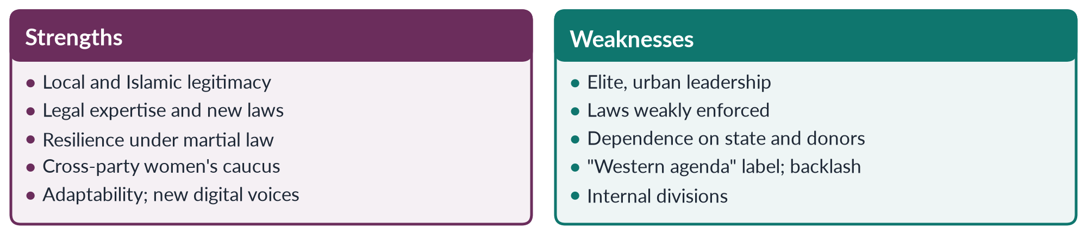
Figure 24 · Strengths and weaknesses at a glance.

11.4 The scorecard today
✦ DATA
Women's status in Pakistan · where the movement stands
Pakistan ranked 143rd of 145 in the Global Gender Gap Report 2026 (after last place, 148th of 148, in 2025). Female labour-force participation is 24.4% (LFS 2024–25). Female literacy is about 53% (Census 2023). Only 11 women won general seats in the National Assembly in 2024.
➜ The movement has changed the law far more than it has changed daily life.

11.4a Lessons of seventy-five years
1. Law is necessary but not sufficient. Every major law since 2006 was a real gain; enforcement and social change are the harder task.
2. Gains depend on political openings. The movement advanced under democratic governments and sympathetic leaders, and was forced onto the defensive under Zia.
3. Legitimacy matters. Demands framed in constitutional and Islamic terms have met less resistance than those seen as foreign.
4. Coalitions win. The laws of 2010–2016 passed because women legislators of all parties, NGOs and activists worked together.
5. Renewal comes from below. Each time the movement seemed to stall — after APWA, after WAF, after NGO-isation — a new generation found new methods.

11.5 The way forward
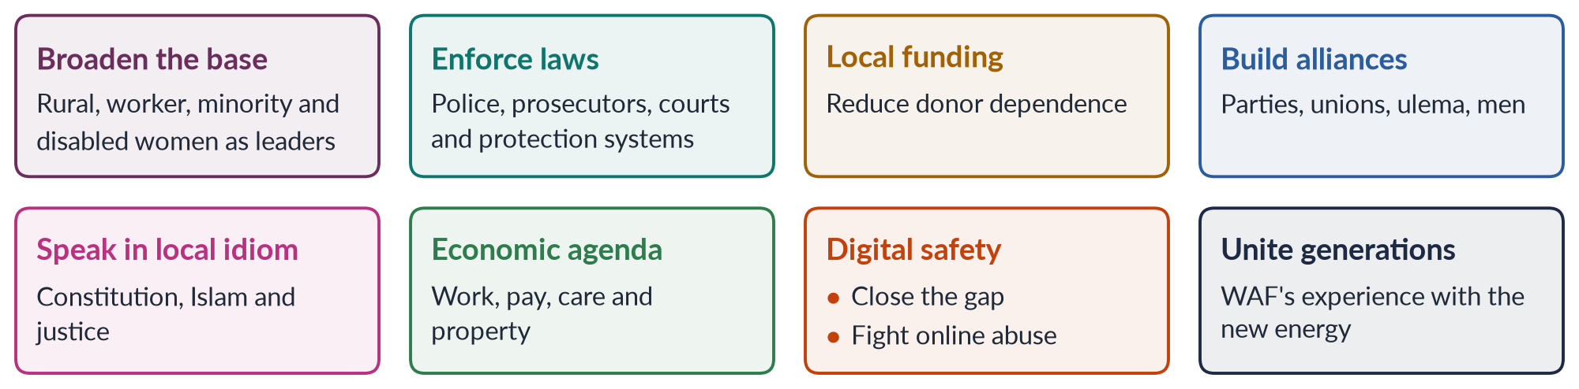
Figure 25 · Eight steps for Pakistan's women's movement.
1. Broaden the base — rural women, workers, minorities, women with disabilities and khawaja siras must lead, not only benefit.
2. Move from law to enforcement — train police and judges; fund shelters and helplines; monitor implementation.
3. Local resources — membership fees, local philanthropy and state budgets for women's institutions.
4. Alliances — with political parties, trade unions, progressive religious scholars and men.
5. Local idiom — frame demands in the Constitution (Articles 25, 34) and Islamic principles of justice and dignity.
6. An economic agenda — jobs, equal pay, childcare, safe transport, property and inheritance.
7. Digital inclusion and safety — close the mobile gender gap; tackle online abuse.
8. Bridge generations — combine WAF's legal experience with the Aurat March's energy.

11.6 Conclusion: two steps forward, one step back?
Mumtaz and Shaheed titled their 1987 history Two Steps Forward, One Step Back? Nearly four decades later, the question mark still fits. The movement has won laws, seats and institutions that its founders could only hope for; girls' education is widely accepted; violence against women is a public issue. Yet Pakistan's ranking, women's low labour-force participation and continuing honour crimes show that daily life has changed more slowly than the statute book. The movement's future depends on turning rights on paper into rights in practice — and on reaching the rural and working women who are the majority.
EXAMINER'S EYE · THE MODEL STRUCTURE FOR 2016
1. Introduction: define the women's movement; Mumtaz and Shaheed. 2. Roots (reform, the Pakistan Movement). 3–6. Phases with dates, organisations and laws. 7. Strengths (six, each with evidence). 8. Weaknesses (six, each with evidence). 9. The scorecard (GGGR 2026, LFPR). 10. Way forward. 11. Conclusion: two steps forward, one step back — but moving. Draw the compare figure.

Part Two — Today's Debates
The 2024–2026 papers ask about emerging trends, digital activism, bodily autonomy and NGO-isation. These are the live debates of Topic 3. Each gives you facts, both sides and a line to take.

Debate 1 · The Aurat March: liberation or provocation?
HOT DEBATE · THE AURAT MARCH
Since 8 March 2018 the Aurat March has brought thousands of women onto the streets of Karachi, Lahore, Islamabad and other cities with demands on violence, harassment, inheritance, workers' rights, khawaja sira rights and bodily autonomy.
• Supporters: it revived street feminism after years of NGO-isation; it is self-funded and volunteer-run; it made women's issues national news; its slogans express real grievances — forced marriage, harassment, domestic labour.
• Critics: some slogans were seen as vulgar or against religion and culture; it is urban and elite; it hands opponents a weapon to discredit all women's rights.
• The state and courts: petitions to ban it were filed; courts generally upheld the right to march under Articles 16 and 17 (assembly and association) while urging "decency".
➜ Line to take: the march's substance — freedom from violence, fair work, inheritance — commands wide support; debate over slogans should not hide it. A peaceful march is a constitutional right.

Debate 2 · Is feminism in Pakistan a Western agenda?
- The charge: foreign-funded NGOs and Western-educated leaders import alien values.
- The reply: local roots (Mumtaz Ali 1898; women in the Pakistan Movement; the Quaid's 1944 speech); Islamic feminism; rural movements such as the Sindhiani Tehreek; and the fact that the main demands — safety, education, inheritance, fair wages — are rooted in the Constitution and in Islam.
- Line to take: tools and platforms came from abroad; the struggle and its reasons are Pakistani (Chapter 9).

Debate 3 · Has the movement moved "from law to the body" — and is that wise?
The 2026 question claims a shift from legal rights to bodily autonomy. Some activists argue that without control over their bodies — freedom from violence, forced marriage and harassment — women cannot use legal rights at all. Others fear that bodily-autonomy language, heard as sexual freedom, provokes backlash and loses allies. The strongest answers show that the two are linked: laws protect bodies, and the new activism still demands laws.

Debate 4 · Can digital activism reach rural women?
✦ DATA
The digital gap · GSMA as cited in CSS 2026
Pakistan's mobile-internet gender gap fell from 38% to 25%, with about eight million more women online (2024–2025).

- Optimists: cheaper smartphones, WhatsApp and voice notes reach women in villages; helplines offer help without leaving home.
- Pessimists: a quarter of the gap remains; men often control family phones; online abuse drives women offline.
- Line to take: digital activism must be paired with offline organising — Lady Health Workers, community groups and local councillors.

Debate 5 · NGO-isation: did donors capture the movement?
Covered in Chapter 10. The line to take: partly — but NGOs also won laws and services, and self-funded movements have revived politics. A division of labour between NGOs and movements is the way forward.

Debate 6 · Beijing+30 and the global backlash
LATEST UPDATE · BEIJING+30 (2025)
The thirtieth-anniversary review of the Beijing Platform, held at the UN Commission on the Status of Women in March 2025, recorded progress in girls' education, legal reform and women's representation, but warned of slow change in power and pay, persistent violence, and a growing backlash against women's rights and "gender" in many countries. The reversal of Roe v. Wade (2022) and restrictions on women in Afghanistan since 2021 are often cited.
➜ For Pakistan: international commitments are only as strong as domestic political will.

Debate 7 · Secular or Islamic feminism — one movement or two?
WAF was secular; many younger and rural activists use Islamic arguments; religious women's organisations run their own campaigns on dowry, inheritance and education. The debate asks whether these can form one movement. Scholars such as Afiya Zia (Faith and Feminism in Pakistan, 2018) warn that faith-based approaches may limit reform; others argue that broad alliances are the only way to reach most women. Line to take: coalitions on shared goals — violence, inheritance, education, child marriage — are possible without agreeing on everything.

Debate 8 · Men and the movement
Men marched in the Aurat March, male legislators voted for the laws of 2010–2016, and male scholars have supported inheritance and consent. Yet men also lead the backlash, online and offline. The debate is how to turn men from gatekeepers into allies (Topic 2, Chapter 6).

Part Three — The Examiner's Record of Topic 3

Every question, 2016–2026
Table 21 · Every question the examiner has set on T3, 2016–2026.
Year · Q | The question (as set) | Family
2016 · Q5 | Write a note on women's movement in Pakistan. What are its strengths and weaknesses? | The women's movement in Pakistan
2018 · Q8(b) | Short note: APWA and WAF | APWA and WAF
2019 · Q3 | Outline and explain the three major waves of feminist movements in the West. Discuss the influence of these waves on feminist movements in Pakistan. | The waves of Western feminism and their influence on Pakistan
2022 · Q4 | Shed light on the first wave and third wave of feminism. | The waves of Western feminism and their influence on Pakistan
2022 · Q6 | Discuss in detail feminist movements in Pakistan. | The women's movement in Pakistan
2023 · Q5 | Outline and explain the three major waves of feminist movements in the West. Discuss the influence of these waves on feminist movements in Pakistan. | The waves of Western feminism and their influence on Pakistan
2024 · Q4 | Write in detail the impact of Western feminist movements on the feminist movement in Pakistan. Compare Pakistani feminist movements of the past with emerging trends of feminist activism and their effects. | The waves of Western feminism and their influence on Pakistan; The women's movement in Pakistan
2025 · Q4 | Discuss the key principles, goals and strategies of the different waves of feminism. How have these waves affected women's lives? | The waves of Western feminism and their influence on Pakistan
2026 · Q3 | Trace the evolution of the feminist movement in Pakistan, from the activism of the Women's Action Forum (WAF) against the Hudood Ordinances in the 1980s to the digital activism of the 2020s. How has the locus of resistance shifted from 'legal rights' to 'bodily autonomy'? | The women's movement in Pakistan
2026 · Q6 | Critically examine the 'NGO-ization' of the women's movement in Pakistan. Has the donor-driven agenda of gender mainstreaming depoliticized the feminist struggle, converting it into a technocratic 'project' rather than a social revolution? Use the WAD (Women and Development) critique in your answer. | NGO-isation of the women's movement; WID, WAD and GAD

What the record reveals
- Nine full questions and one short note in eleven papers — a steady, mid-weight topic (9.5 visits), and 22 of the 140 MCQs.
- Two families carry it. The waves (2019, 2022, 2023, 2024, 2025) and the movement in Pakistan (2016, 2022, 2024, 2026, plus APWA/WAF in 2018 and NGO-isation in 2026).
- An exact repeat. 2019 Q3 and 2023 Q5 are word-for-word the same. The examiner is willing to repeat — learn the waves-and-Pakistan answer thoroughly.
- The link is always wanted. Four of the five waves questions ask about Pakistan or women's lives.
- Every Pakistan question has a twist: strengths and weaknesses (2016), past versus emerging trends (2024), legal rights to bodily autonomy (2026), NGO-isation and the WAD critique (2026).
- The questions are getting sharper. 2026 quoted scholarly phrases — "locus of resistance", "technocratic project", "depoliticized".
- The UN has never been a full question, though MCQs on Mexico 1975, Beijing 1995 and CEDAW 1996 recur. It is due.

Five likely questions
1. "Critically evaluate the contribution of the four UN World Conferences on Women to the global women's movement. What has Beijing+30 revealed?" (Chapter 6.)
2. "Is there a fourth wave of feminism? Discuss its features and its expression in Pakistan." (Chapters 4 and 9.)
3. "The Aurat March has divided Pakistani society. Discuss its demands, its critics and its significance." (Chapters 8, 9 and Part Two.)
4. "Discuss the role of the Women's Action Forum in the struggle against discriminatory laws in the 1980s." (Chapter 8.)
5. "How far has the women's movement in Pakistan succeeded in translating activism into law and law into change?" (Chapters 8 and 11.)
These are not solved here; the Prediction Papers include answers to predicted questions. Plan each as an answer map for practice.

Part Four — The One-Liner Bank
About 120 one-liners in the style of the past MCQs. Each is a complete, checkable fact: the key word is in bold green and the date in bold navy. Read them aloud; cover the bold words and test yourself; then attempt every past MCQ below.

The one-liners

A · The waves in general
1. A wave of feminism is a period of intense activity with shared demands; the metaphor was popularised by Martha Weinman Lear in 1968.
2. The first wave (c. 1848–1920) fought for the vote, property, education and legal personhood.
3. The second wave (1960s–1980s) fought over work, family, sexuality and the body.
4. The third wave (1990s–2000s) stressed diversity, identity and intersectionality.
5. The fourth wave (from about 2012) is defined by digital activism against harassment and violence.
6. Critics say the wave metaphor follows white, Western, middle-class history and hides activism between waves.

B · The first wave
7. Coverture meant a married woman's legal identity was covered by her husband's.
8. Stanton and Mott were excluded from the World Anti-Slavery Convention in London (1840) and resolved to hold Seneca Falls (MCQ 2024).
9. The Seneca Falls Convention was held on 19–20 July 1848 in New York.
10. The Seneca Falls Convention was led by Elizabeth Cady Stanton (MCQ 2025).
11. The Declaration of Sentiments declared: "all men and women are created equal".
12. Frederick Douglass signed the Declaration of Sentiments.
13. Susan B. Anthony and Stanton founded the National Woman Suffrage Association in 1869.
14. Wyoming Territory gave women the vote in 1869.
15. The 19th Amendment gave American women the vote in 1920.
16. New Zealand was the first self-governing country to give women the national vote (1893), after Kate Sheppard's campaign.
17. Finland (1906) was the first European country to give women the vote and the right to stand.
18. The NUWSS (1897), led by Millicent Fawcett, were the peaceful suffragists.
19. The WSPU (1903), led by Emmeline Pankhurst, were the militant suffragettes — "Deeds, not words".
20. The "Cat and Mouse Act" (1913) released hunger-striking suffragettes and re-arrested them.
21. Emily Wilding Davison died after running onto the course at the Epsom Derby in 1913.
22. British women over 30 with property won the vote in 1918; equal votes at 21 came in 1928.
23. Caroline Norton's campaign led to the Custody of Infants Act (1839).
24. Britain's Married Women's Property Acts were passed in 1870 and 1882.
25. Elizabeth Blackwell was the first woman to earn a medical degree in the USA (1849).
26. Huda Shaarawi founded the Egyptian Feminist Union in 1923.

C · The second wave
27. "The personal is political" is most associated with second-wave feminism (MCQ 2026).
28. Betty Friedan's The Feminine Mystique (1963) described "the problem that has no name".
29. The National Organization for Women (NOW) was founded in 1966.
30. The US Equal Pay Act was passed in 1963; Title VII of the Civil Rights Act in 1964.
31. The contraceptive pill was approved in the USA in 1960.
32. The 1973 US Supreme Court case that legalised abortion was Roe v. Wade (MCQ 2025).
33. Roe v. Wade was overturned by Dobbs v. Jackson in 2022.
34. The Miss America protest (1968) used a "freedom trash can"; no bras were actually burned.
35. The Ford Dagenham machinists' strike (1968) led to Britain's Equal Pay Act 1970.
36. Britain's first National Women's Liberation Conference met at Ruskin College, Oxford, in 1970.
37. The first modern women's shelter opened in Chiswick, London, in 1971.
38. Gloria Steinem co-founded Ms. magazine (1972).
39. The US Equal Rights Amendment passed Congress in 1972 but was never ratified; Phyllis Schlafly led the opposition.
40. The "Manifesto of the 343" (France, 1971) was signed by women who admitted illegal abortions.
41. On 24 October 1975 about 90% of Icelandic women went on a "day off".
42. Susan Faludi's Backlash (1991) described the counter-attack on feminism in the 1980s.

D · The third wave
43. The Anita Hill hearings (1991) sparked the third wave.
44. The term Third Wave feminism was coined by Rebecca Walker (MCQ 2025) in Ms. (1992).
45. Walker wrote: "I am not a post-feminism feminist. I am the Third Wave."
46. Riot Grrrl (from 1991) used punk music and zines to spread feminism.
47. Naomi Wolf wrote The Beauty Myth (1990).
48. Eve Ensler's The Vagina Monologues (1996) led to the global V-Day campaign.
49. The US Violence Against Women Act was passed in 1994.
50. Postfeminism claims equality has been won; Angela McRobbie criticised it.
51. "Choice feminism" — calling any individual choice feminist — is a common criticism of the third wave.
52. Women Living Under Muslim Laws (1984) is a transnational network linking activists, including Pakistanis.

E · The fourth wave
53. Kira Cochrane (All the Rebel Women, 2013) argued a fourth wave had begun.
54. The phrase "Me Too" was first used by Tarana Burke in 2006; #MeToo went global in October 2017.
55. SlutWalk began in Toronto in 2011.
56. The Everyday Sexism Project was founded by Laura Bates in 2012.
57. #NiUnaMenos ("Not one less") began in Argentina in 2015.
58. India's Criminal Law (Amendment) Act 2013 followed protests over the Delhi gang rape of 2012.
59. Ireland removed its constitutional ban on abortion by referendum on 25 May 2018.
60. Iran's "Woman, Life, Freedom" protests began in September 2022.
61. Pakistan's mobile-internet gender gap fell from 38% to 25% (GSMA, 2024–25).

F · The United Nations
62. The UN Charter (1945) affirms "the equal rights of men and women".
63. The Commission on the Status of Women was set up in 1946.
64. International Human Rights Day is observed on 10 December (MCQ 2018) — the date of the UDHR (1948).
65. 1975 was International Women's Year; 1976–1985 was the UN Decade for Women.
66. The first UN conference on women was held in Mexico City (1975) (MCQ 2016).
67. The second conference was held in Copenhagen (1980), where CEDAW was opened for signature.
68. The third conference, in Nairobi (1985), adopted the Forward-Looking Strategies.
69. The Fourth World Conference on Women was held in Beijing (MCQ 2019) in 1995.
70. The Beijing Declaration and Platform for Action was adopted in 1995 (MCQs 2024, 2026).
71. The Beijing Platform has 12 critical areas of concern and was adopted by 189 governments.
72. The Beijing conference identified women's vital role in environmental management (MCQ 2023) — critical area K.
73. Beijing endorsed gender mainstreaming.
74. CEDAW was adopted on 18 December 1979 and entered into force on 3 September 1981.
75. CEDAW is often described as an international bill of rights for women (MCQ 2026).
76. Pakistan acceded to CEDAW in 1996 (MCQs 2016, 2018, 2019), on 12 March.
77. Pakistan made a general declaration (subject to the Constitution) and a reservation to Article 29(1).
78. CEDAW Article 4 permits temporary special measures such as quotas.
79. CEDAW Article 14 concerns rural women; Article 16 concerns marriage and family.
80. CEDAW's Optional Protocol (1999) allows individual complaints; Pakistan has not joined it.
81. The Vienna Conference (1993) declared "women's rights are human rights"; DEVAW followed in December 1993.
82. UN Security Council Resolution 1325 (2000) concerns Women, Peace and Security.
83. UN Women was created in 2010; its first head was Michelle Bachelet.
84. SDG 5 (2015) aims to "achieve gender equality and empower all women and girls".
85. Beijing+30 was reviewed at the CSW in March 2025.
86. DAWN (1984) is a network of Southern feminists.

G · Roots in South Asia
87. The reformer who advocated women's education and opposed sati was Raja Ram Mohan Roy (MCQ 2026); sati was banned in 1829.
88. Ishwar Chandra Vidyasagar campaigned for the Hindu Widows' Remarriage Act (1856).
89. Sayyid Mumtaz Ali wrote Huquq-un-Niswan (1898) and ran Tahzib-e-Niswan with Muhammadi Begum.
90. The Child Marriage Restraint Act ("Sarda Act") was passed in 1929.
91. The Dissolution of Muslim Marriages Act was passed in 1939.
92. The Muslim League formed a Central Women's Sub-Committee at Patna in 1938.
93. Begum Jahanara Shahnawaz was the only Muslim woman delegate at the Round Table Conferences.
94. Jahanara Shahnawaz and Shaista Ikramullah were the first women in Pakistan's Constituent Assembly (1947).
95. Fatima Sughra hoisted the Muslim League flag on the Punjab Civil Secretariat in 1947.
96. Fatima Jinnah is called Madar-e-Millat and contested the presidential election of 1965.

H · The movement in Pakistan
97. The All Pakistan Women's Association (APWA) was formed in 1949 (MCQ 2018).
98. APWA was founded by — and its first president was — Begum Ra'ana Liaquat Ali Khan (MCQs 2016, 2019).
99. The West Punjab Muslim Personal Law (Shariat) Application Act 1948 gave women inheritance in agricultural land.
100. PM Bogra's second marriage (1955) led to the Rashid Commission on marriage and family laws.
101. The Muslim Family Laws Ordinance was promulgated in 1961 under Ayub Khan.
102. The Hudood Ordinances were enacted in 1979 (MCQ 2016) under Zia-ul-Haq (MCQ 2019).
103. A major focus of Pakistan's women's movement in the 1980s was the Hudood Ordinances (MCQ 2025).
104. The Women's Action Forum was founded in Karachi in 1981 after the Fehmida–Allah Bux case.
105. On 12 February 1983 police baton-charged WAF and women lawyers in Lahore; the day became National Women's Day in 2012.
106. The Safia Bibi case (1983) exposed how the Zina Ordinance punished rape victims.
107. The Qanun-e-Shahadat (Law of Evidence) was enacted in 1984.
108. Khawar Mumtaz and Farida Shaheed wrote Women of Pakistan: Two Steps Forward, One Step Back? (1987).
109. Benazir Bhutto became the first woman prime minister of a Muslim country in 1988.
110. The First Women Bank opened in 1989; the first women's police station in 1994.
111. The NCSW was set up in 2000; 60 reserved NA seats came in 2002.
112. The Protection of Women Act 2006 moved rape from the Zina Ordinance to the Penal Code.
113. The Women's Parliamentary Caucus was formed in 2008; Fahmida Mirza became the first woman Speaker.
114. The killing of Qandeel Baloch (2016) spurred the honour-killing amendment of October 2016.
115. The first Aurat March was held on 8 March 2018.
116. The slogan "Mera Jism Meri Marzi" ("My body, my choice") provoked controversy in 2019–20.
117. The Sindhiani Tehreek (from 1982) was a mass movement of rural Sindhi women.
118. Al-Huda was founded in 1994 by Farhat Hashmi.
119. Asma Jahangir co-founded the HRCP (1987) and AGHS Legal Aid.
120. Sharmeen Obaid-Chinoy's A Girl in the River (Oscar 2016) added pressure for the honour-killing law.

I · NGO-isation and evaluation
121. NGO-isation means a movement turning into professional, donor-funded NGOs with projects and upward accountability.
122. Sonia Alvarez (1999) and Islah Jad (2004) wrote on NGO-isation.
123. WAD (Women and Development) says women were always part of development but on unequal, exploitative terms.
124. Shirkat Gah was founded in 1975; Aurat Foundation in 1986.
125. The Sindh Home-Based Workers Act (2018) was the first such law in Pakistan.
126. The movement's greatest weakness is the gap between laws and enforcement; its greatest strength, its local and constitutional legitimacy.

Every past MCQ on Topic 3
Table 22 · Every recovered MCQ on T3, with its key.
Year | Question | Key
2016 · 1 | First conference of women in the UNO was held in: | A - Mexico
2016 · 8 | The Hudood Ordinances were enacted in: | D - 1979
2016 · 15 | Pakistan acceded to CEDAW in: | A - 1996
2016 · 17 | First president of the All Pakistan Women's Association: | A - Begum Ra'ana Liaquat Ali Khan
2018 · 3 | International Human Rights Day is observed on: | D - 10 December
2018 · 5 | Pakistan ratified/acceded to CEDAW in: | B - 1996
2018 · 12 | The All Pakistan Women's Association was formed in: | C - 1949
2019 · 1 | The Hudood Ordinances were enforced during the rule of: | C - Zia-ul-Haq
2019 · 2 | The Fourth World Conference on Women was held in: | A - Beijing
2019 · 11 | Pakistan acceded to CEDAW in: | C - 1996
2019 · 14 | APWA was founded by: | B - Begum Ra'ana Liaquat Ali Khan
2023 · 14 | Which conference identified women's vital role in environmental management? | C - Beijing
2024 · 3 | Who were excluded from the World Anti-Slavery Convention and resolved to hold the Seneca Falls Convention? | B - Elizabeth Cady Stanton and Lucretia Mott
2024 · 7 | The Beijing Declaration and Platform for Action was adopted in: | D - None of these; it was adopted in 1995
2025 · 11 | The Seneca Falls Convention was led by: | C - Elizabeth Cady Stanton
2025 · 12 | The 1973 US Supreme Court case that legalized abortion was: | A - Roe v. Wade
2025 · 16 | A major focus of Pakistan's women's-rights movement in the 1980s was: | A - Hudood Ordinances
2025 · 20 | The term Third Wave Feminism was coined by: | B - Rebecca Walker
2026 · 6 | 'The personal is political' is most associated with: | B - Second-wave feminism
2026 · 8 | Which UN Conference resulted in the Platform for Action? | C - Beijing 1995
2026 · 16 | The subcontinental reformist movement advocating women's education and opposing sati was led by: | D - None of these; Raja Ram Mohan Roy
2026 · 18 | CEDAW is often described as: | A - An international bill of rights for women

TRAP · THREE MCQ TRAPS IN TOPIC 3
1. Signed, ratified or acceded? Pakistan acceded to CEDAW in 1996 — it did not sign first. Options may say "ratified"; 1996 is still the year to choose.
2. Adopted versus in force. CEDAW was adopted in 1979 and entered into force in 1981. Beijing's Platform was adopted in 1995; if 1995 is missing, choose "none of these" (MCQ 2024).
3. Founder versus first president. For APWA the answer to both is Begum Ra'ana Liaquat Ali Khan; do not confuse APWA (1949) with WAF (1981).

Part Five — The Revision Sheet
The whole of Topic 3 in a few pages, for the night before the exam. Every term is explained where it appears, so you will not need to turn back to the chapters.

1. The waves in general
- Women's movement — collective, organised action over time to improve women's rights and status.
- Wave — a period of intense feminist activity with shared demands. Metaphor made popular by Martha Weinman Lear, "The Second Feminist Wave" (New York Times Magazine, 1968); the earlier suffrage campaign then became the "first wave".
- The four waves — first (c. 1848–1920: vote, property, education, legal personhood); second (1960s–80s: work, family, body, sexuality; "the personal is political"); third (1990s–2000s: diversity, identity, intersectionality, culture); fourth (c. 2012–: digital activism against harassment and violence).
- Critics of the metaphor — it follows white, Western, middle-class history; hides activism between waves; makes generations seem to reject each other; ignores the different timing of the global South. Use it as a map, not a law.

2. The first wave (c. 1848–1920)
- What women lacked — the vote; coverture (a married woman's legal identity "covered" by her husband's: no property, contracts or own wages); universities and professions closed; fathers got custody of children.
- Roots — Enlightenment "rights of man"; Olympe de Gouges (1791), Wollstonecraft (1792); training in the anti-slavery movement.
- USA — Stanton and Mott refused seats at the World Anti-Slavery Convention, London (1840) → Seneca Falls Convention (19–20 July 1848, New York; about 300 attended, about 100 signed, including Frederick Douglass) → Declaration of Sentiments: "all men and women are created equal"; demand for the vote. Anthony and Stanton's NWSA (1869); merged with AWSA in 1890; Sojourner Truth (1851); Wyoming vote (1869); Alice Paul pickets (1917); 19th Amendment (1920).
- Britain — suffragists: NUWSS (1897), Millicent Fawcett, peaceful methods (petitions, lobbying). Suffragettes: WSPU (1903), Emmeline and Christabel Pankhurst, "Deeds, not words" — window-smashing, arson, hunger strikes; Cat and Mouse Act (1913: hunger strikers released when weak, re-arrested later); Emily Wilding Davison died at the Derby (1913). 1918 Act: women over 30 with property; 1928: equal votes at 21. War work in 1914–18 helped.
- Other campaigns — Caroline Norton → Custody of Infants Act (1839); Matrimonial Causes Act (1857, divorce); Married Women's Property Acts (1870, 1882); Elizabeth Blackwell first US woman medical graduate (1849); Girton College (1869); Josephine Butler against the Contagious Diseases Acts (repealed 1886); temperance.
- Around the world — New Zealand 1893 (Kate Sheppard, first self-governing country); Australia 1902; Finland 1906 (first in Europe; could also stand); Turkey 1934; France 1944; India and Pakistan 1947 (with independence). Muslim world: Huda Shaarawi, Egyptian Feminist Union (1923).
- Principles, goals, strategies — women are rational citizens (liberal); vote, property, education, custody; conventions, petitions, lobbying, newspapers, militancy.
- Limits — mostly white and middle-class (Black Southern women barred until the Voting Rights Act 1965); legal, not social, equality; Western timing.
- Pakistan — vote came with independence; first-wave goals (education, property, legal status) shaped APWA, the 1948 Punjab inheritance Act and the MFLO 1961.

3. The second wave (1960s–1980s)
- Why — vote won but inequality in pay, jobs, family, body; the "feminine mystique"; causes: wartime work, more women at university, the pill (US 1960), the civil-rights movement, Beauvoir (1949).
- Two streams — liberal/equal rights: Friedan, The Feminine Mystique (1963, "the problem that has no name"); NOW (1966); lobbying, lawsuits. Women's liberation/radical: New York Radical Women, Redstockings; Millett, Firestone, Hanisch (1970); consciousness-raising (small groups turning private problems into political awareness), direct action.
- Key events — Kennedy's Commission on the Status of Women (1961); US Equal Pay Act (1963); Title VII (1964); UK Abortion Act (1967); Miss America protest (1968, "freedom trash can"); Ford Dagenham strike (1968) → UK Equal Pay Act 1970; Ruskin College conference (1970; four demands: equal pay, equal education and opportunity, 24-hour nurseries, free contraception and abortion on demand); Chiswick shelter (1971); Ms. (Steinem, 1972); ERA passed Congress (1972, never ratified — Phyllis Schlafly); Title IX (1972); Roe v. Wade (22 January 1973; overturned by Dobbs 2022); UK Sex Discrimination Act (1975); Manifesto of the 343 (France 1971); Iceland women's day off (24 Oct 1975, ~90%); CEDAW (1979).
- "The personal is political" (Carol Hanisch, 1970) — private problems (housework, marriage, sex, abortion) are shaped by power; most associated with the second wave (MCQ 2026).
- Voices — Steinem, Germaine Greer (The Female Eunuch, 1970), Millett, Firestone, MacKinnon (harassment as discrimination, 1979), Angela Davis (1981).
- Achievements — equal pay and anti-discrimination laws; contraception and abortion rights; shelters, rape crisis centres; harassment law; Women's Studies.
- Blind spots — white and middle-class (bell hooks, 1981; Audre Lorde); heterosexual bias (Friedan's "lavender menace", 1969); Western focus (Mexico City 1975 tensions); backlash (Faludi, Backlash, 1991).
- Why it faded — success; divisions ("sex wars"); Reagan–Thatcher conservatism; ERA deadline missed (1982); institutionalisation.
- Pakistan — WAF (1981) against the Hudood Ordinances (1979): a second-wave struggle over body, sexuality and violence; later harassment (2010) and honour (2016) laws.

4. The third wave (1990s–2000s)
- Spark — Anita Hill hearings (Oct 1991): she testified that Clarence Thomas harassed her; harsh questioning by an all-male committee.
- Name — Rebecca Walker, "Becoming the Third Wave", Ms. (January 1992): "I am not a post-feminism feminist. I am the Third Wave" (MCQ 2025); Third Wave Direct Action Corporation (1992).
- Theory — intersectionality (Crenshaw 1989; hooks; Combahee 1977); postmodern/queer (Butler 1990, gender performative); postcolonial (Mohanty 1984).
- Features — diversity (many womanhoods); intersectionality; individual choice; sex-positivity and reclaiming words; culture — Riot Grrrl (1991, zines = homemade magazines; Bikini Kill); Naomi Wolf, The Beauty Myth (1990); Eve Ensler, The Vagina Monologues (1996) → V-Day (1998); Manifesta (2000); "girl power"; global voices.
- Laws and campaigns — US Violence Against Women Act (1994); Vienna (1993) "women's rights are human rights"; DEVAW (1993); Beijing (1995); 16 Days of Activism (from 1991); WLUML (1984), Sisters in Islam (1988), Wadud (1992).
- Postfeminism — claim that equality is won and feminism unnecessary; criticised by Angela McRobbie, Faludi; third wave defined itself against it.
- Criticisms — too individual ("choice feminism"); consumerism ("girl power" as marketing); fragmentation; caricature of the second wave.
- Effects — voice for women of colour, LGBT and Southern women; intersectionality in law and policy; harassment reporting; violence as a human-rights issue.
- Pakistan — Beijing (1995; Benazir Bhutto spoke), NGO boom, attention to rural and minority women, khawaja siras (SC 2009; Act 2018), Islamic feminism (Riffat Hassan, Asma Barlas).

5. The fourth wave (c. 2012–)
- Definition — feminist activism using social media to share experience, expose harassment and violence, organise quickly and hold the powerful accountable; intersectional. Kira Cochrane, All the Rebel Women (2013).
- Campaigns — SlutWalk (Toronto 2011); Everyday Sexism Project (Laura Bates 2012); Delhi gang-rape protests (Dec 2012) → India's Criminal Law (Amendment) Act 2013; #NiUnaMenos (Argentina 2015; abortion legal Dec 2020); Women's March (21 Jan 2017); #MeToo (Tarana Burke 2006; global October 2017 after the Weinstein reports; Alyssa Milano); Ireland's referendum (25 May 2018); Spain's consent law (2022); Iran's "Woman, Life, Freedom" (Sept 2022).
- Features — digital tools; harassment and violence; intersectionality; bodily autonomy and consent; accountability ("call-out culture"); global speed.
- Criticisms — online abuse and doxxing (publishing private details); "slacktivism"; due-process concerns; digital divide; manosphere backlash.
- Pakistan — Aurat March (from 8 March 2018); #MeToo (2018); Digital Rights Foundation (2012; helpline 2016); PECA 2016; outrage after Qandeel Baloch (2016), the motorway gang rape (2020), Noor Mukadam (2021) → Anti-Rape (Investigation and Trial) Act 2021; mobile-internet gender gap 38% → 25% (GSMA, 2024–25).

6. The waves compared (2025)
- Principles — first: equal natural rights; second: personal is political, patriarchy; third: diversity, intersectionality, choice; fourth: consent, accountability, intersectionality.
- Goals — first: vote, property, education; second: pay, jobs, reproduction, violence; third: inclusion, sexuality, identity, global rights; fourth: end harassment and violence, safe spaces.
- Strategies — first: petitions, conventions, militancy; second: lobbying, lawsuits, consciousness-raising; third: culture, zines, networks; fourth: hashtags, testimony, mass marches.
- Theory — first liberal; second liberal, radical, socialist; third Black, postmodern, queer, postcolonial; fourth intersectional.
- Effects on women's lives — political (vote; about a quarter of parliamentarians worldwide are women); legal (property, contracts, divorce; discrimination unlawful); education and work (women at university and in all professions; pay gaps remain); body (contraception, safe abortion in many countries); safety (violence criminalised; shelters); voice (diverse women; harassment costly).
- Continuity vs change — new leaders, issues and methods each time, but one core demand: equal dignity and freedom. Treat the waves as stages of one movement.
- Unfinished — global gap 69.2% closed (2026), 120 years to parity; one in three women faces violence (WHO 2021); Roe reversed (2022); Pakistan 143rd of 145.
- Pakistan's waves — first ≈ welfare and reform (1947–70); second ≈ legal resistance (1980s); third ≈ NGOs and diversity (1990s–2000s); fourth ≈ Aurat March and digital (2018–). Phases overlap.

7. The United Nations and women
- Foundations — UN Charter (1945, "equal rights of men and women"); CSW (21 June 1946, meets each March); UDHR (10 December 1948 = Human Rights Day, MCQ 2018); Convention on the Political Rights of Women (1952); DEDAW (1967).
- International Women's Year 1975; UN Decade for Women 1976–85 ("Equality, Development and Peace").
- Four conferences — Mexico City 1975 (first; World Plan of Action; UNIFEM/INSTRAW; North–South tensions; MCQ 2016); Copenhagen 1980 (mid-decade; CEDAW signing ceremony; employment, health, education); Nairobi 1985 (Forward-Looking Strategies to 2000; large NGO forum); Beijing 1995 (4–15 September; 189 governments; Beijing Declaration and Platform for Action; 12 critical areas; gender mainstreaming; NGO forum at Huairou ~30,000; "women's rights are human rights"; Benazir Bhutto spoke).
- 12 critical areas — poverty; education; health; violence; armed conflict; economy; power and decision-making; institutional mechanisms; human rights; media; environment (area K → MCQ 2023); the girl child.
- Reviews — Beijing +5 (2000), +10, +15, +20, +25 (2020), +30 (March 2025): progress in education and laws; slow change in power and pay; violence; backlash.
- CEDAW — adopted 18 Dec 1979; in force 3 Sept 1981; "an international bill of rights for women" (MCQ 2026); Committee of 23 experts; reports every four years; Optional Protocol 1999 (individual complaints; Pakistan not a party). Key articles: 1 (definition), 2 (change laws and customs), 4 (temporary special measures, e.g., quotas), 5 (stereotypes), 7 (political life), 10 (education), 11 (employment), 12 (health), 14 (rural women), 16 (marriage and family), 29 (disputes → ICJ).
- Pakistan and CEDAW — acceded 12 March 1996 (accession = joining without prior signature); general declaration (subject to the Constitution) and reservation to Article 29(1); periodic reports; NGO shadow reports; Committee urges repeal of discriminatory laws, enforcement against violence and child marriage.
- Wider agenda — Vienna 1993; DEVAW (Dec 1993); Cairo ICPD 1994; UNSCR 1325 (31 Oct 2000, Women, Peace and Security); MDGs (2000); UN Women (July 2010, operational 2011; Michelle Bachelet; merged four bodies incl. UNIFEM); SDG 5 (2015); HeForShe (2014); Generation Equality Forum (2021); DAWN (1984).
- Assessment — achievements: global standards, violence as a human-rights issue, national machineries, NGO platforms. Limits: no enforcement; reservations; implementation gaps; "Western values" charge.
- What it gave Pakistan — Women's Division (1979); National Plan of Action (1998); NCSW (2000); National Policy (2002); reserved seats (2002); an international platform for activists.

8. Roots in South Asia and the Pakistan Movement
- Social reform — Raja Ram Mohan Roy → Bengal Sati Regulation (1829; MCQ 2026); Vidyasagar → Widows' Remarriage Act (1856); Tarabai Shinde (1882); Age of Consent Act (1891, 10 → 12); Child Marriage Restraint Act (Sarda Act) 1929; Dissolution of Muslim Marriages Act 1939; Shariat Application Act (1937).
- Muslim reform — Nazir Ahmad, Mirat-ul-Uroos (1869); Mumtaz Ali, Huquq-un-Niswan (1898) and Tahzib-e-Niswan with Muhammadi Begum; Sheikh Abdullah and Wahid Jahan Begum's Aligarh girls' school (1906); Begum Rokeya (1905, 1911); All-India Muslim Ladies' Conference (from 1914). Pattern: reform within tradition; education first.
- Pakistan Movement — Muslim League Central Women's Sub-Committee (Patna 1938); Fatima Jinnah (Madar-e-Millat); Jahanara Shahnawaz (only Muslim woman at the Round Table Conferences; first Constituent Assembly with Shaista Ikramullah, 1947); Ra'ana Liaquat Ali Khan; Lady Abdullah Haroon (Sindh); Salma Tassaduq Hussain, Viqar-un-Nisa Noon (1947 Punjab agitation); Fatima Sughra (flag on Punjab Civil Secretariat, Feb 1947). Quaid, Aligarh, 10 March 1944: "No nation can rise to the height of glory unless your women are side by side with you."
- Partition — abductions and violence; women's relief work → Women's Voluntary Service, Women's National Guard → APWA 1949.
- Inheritance 1948 — women legislators and a demonstration outside the Punjab Assembly → West Punjab Muslim Personal Law (Shariat) Application Act 1948 (inheritance incl. agricultural land): rights won by appealing to Islam against custom.
- What roots explain — reform from within Islam; education first; elite leadership; ties to nationalism; vote came with independence.

9. The movement in Pakistan — six phases
- Phase 1 · Welfare and reform (1947–70) — APWA (1949, founder and first president Begum Ra'ana Liaquat Ali Khan; schools, colleges, clinics, crafts; non-political welfare); PM Bogra's second marriage (1955) → Rashid Commission (report 1956) → MFLO 1961 (Ayub: registration of marriage; arbitration council permission for second marriage; divorce notice; orphaned grandchildren inherit); 1956 Constitution reserved seats; Fatima Jinnah vs Ayub (1965).
- Phase 2 · Constitutional equality (1971–77) — 1973 Constitution: Art. 25 (no sex discrimination), 27 (public service), 32 (women in local government), 34 (full participation), 35 (family); Ra'ana Liaquat Governor of Sindh (1973); IWY committee (1975).
- Phase 3 · Resistance under Zia (1977–88) — Hudood Ordinances (Feb 1979; zina, theft, drink, false accusation; rape victims who could not prove rape risked zina charges); WAF (Karachi, Sept 1981, after the Fehmida–Allah Bux stoning sentence; non-hierarchical, non-party, secular); 12 February 1983 Lahore protest against the Law of Evidence (WAF and Punjab Women Lawyers' Association; baton charge; Habib Jalib; National Women's Day since 2012); Safia Bibi (1983, visually impaired rape victim convicted of zina; FSC acquitted her); Qanun-e-Shahadat 1984 (Art. 17: two women witnesses in financial matters); Qisas and Diyat (1990/1997, "forgiveness" loophole); Zari Sarfaraz Commission (1983–85, shelved); Sindhiani Tehreek (1982).
- APWA vs WAF — APWA: 1949; Ra'ana Liaquat; welfare, education, skills; service and cooperation with the state; non-political; elite charity. WAF: 1981; resist discriminatory laws; protest, lobbying, legal analysis; secular, non-party, confrontational; professional urban women.
- Phase 4 · Democracy, Beijing, NGOs (1988–99) — Benazir Bhutto (1988, first woman PM of a Muslim country); First Women Bank (1989); women's police stations and LHW Programme (1994); Beijing (1995); CEDAW (1996); NGO boom (Shirkat Gah 1975, Aurat Foundation 1986, Simorgh, ASR); HRCP (1987); Samia Sarwar (1999, honour killing).
- Phase 5 · Reforms and machinery (2000–17) — NCSW (2000); 33% local seats (2001); 60 NA / 17 Senate reserved seats (2002); National Policy (2002); Criminal Law (Amendment) Act 2004 (honour crimes); Protection of Women Act 2006 (rape to Penal Code); Women's Parliamentary Caucus, Fahmida Mirza Speaker, BISP (2008); harassment (2010); acid, anti-women practices (2011); honour and anti-rape amendments, Punjab PWVA (2016, after Qandeel Baloch); Elections Act 2017 (5% tickets; 10% women's turnout). = state feminism (rights through the state).
- Phase 6 · New activism (2018–) — Aurat March (8 March 2018: violence, harassment, workers, khawaja siras, bodily autonomy); Women Democratic Front, Hum Auratein (2018); digital activism; Anti-Rape Act 2021; Women's Property Rights Act 2020; ICT Child Marriage Restraint Act 2025 (18); ICT Domestic Violence Act 2025; backlash (petitions, "Haya March", online abuse).
- Other actors — rural and working women (Sindhiani Tehreek; Okara tenants from 2000; LHW union, SC 2012; Sindh Home-Based Workers Act 2018; fisherfolk women); religious women (Jamaat-e-Islami women's wing; Al-Huda, 1994, Farhat Hashmi); artists (Kishwar Naheed, Fahmida Riaz; Tehrik-e-Niswan 1979, Sheema Kermani; Ajoka 1984, Madeeha Gauhar; Sharmeen Obaid-Chinoy, Saving Face 2012, A Girl in the River 2016); lawyers (Asma Jahangir, Hina Jilani: first all-women law firm 1980, AGHS Legal Aid, HRCP 1987); legislators (caucus 2008).
- History to quote — Khawar Mumtaz and Farida Shaheed, Women of Pakistan: Two Steps Forward, One Step Back? (1987).

10. Western influence, past vs emerging, and the shift to the body
- Channels — education; the UN (conferences, CEDAW, SDGs); donors and NGOs; media; diaspora scholars.
- Wave by wave — first: education, property (vote came with independence; MFLO argued in Islamic terms); second: personal is political, violence (WAF vs Hudood; focus on law); third: diversity, NGOs, human rights (Beijing, CEDAW, Islamic feminism); fourth: digital, #MeToo, bodily autonomy (Aurat March).
- Not a copy — local roots; waves arrived out of order and together; adapted to Islam and culture; faced a state using religion to restrict women; postcolonial critique is itself Southern. Verdict: West supplied tools and platforms; Pakistani women chose and adapted them.
- Laws showing influence — Harassment Act 2010 (CEDAW Art. 11); reserved seats 2002 (CEDAW Art. 4, Beijing area G); NCSW 2000 (Beijing area H; Act 2012); honour law 2016 (global campaigns; framed in Islamic and constitutional terms); ICT child-marriage law 2025 (SDG 5.3; CEDAW Art. 16).
- Past vs emerging (2024) — past: elite and professional leaders; APWA, WAF, NGOs; welfare, family law, discriminatory laws; lobbying, courts, press; language of Constitution and Islam; cooperation or legal resistance. Emerging: young urban women, students, workers, trans activists; Aurat March collectives, WDF; body, violence, harassment, care, online safety; marches, art, social media; language of consent and intersectionality; independent, confrontational. Effects: visibility; inclusion; faster state response (2020 case → 2021 law); backlash and polarisation; class limits (digital divide).
- Legal rights → bodily autonomy (2026) — locus of resistance = where a movement concentrates its struggle. 1980s WAF: fight laws via courts and lawyers, language of citizenship and Islam. 2020s Aurat March: claim body, safety and choice via streets and social media, language of consent. Why: many legal battles won but violence continues; new generation; fourth-wave influence; the body as the site of control (honour, forced marriage, harassment). Continuity: the march still demands laws; WAF already defended bodies. Formula: from rights on paper to rights over one's own body.
- Why bodily autonomy provokes — body linked to family izzat (honour); critics hear rejection of family and religion; supporters cite Islam's ban on forced marriage and Article 14 (dignity); wide agreement on substance.

11. NGO-isation (2026)
- NGO-isation — movement energy moves into professional, registered, donor-funded NGOs; activists become staff; campaigns become projects; accountability upwards to donors. Scholars: Sonia Alvarez (1999), Islah Jad (2004).
- Depoliticisation — turning a struggle about power into a technical problem managed by experts ("technocratic project" vs "social revolution").
- WAD — 1970s Marxist/dependency critique of WID (integrate women into development): women were always part of development, but on unequal, exploitative terms; adding women to projects leaves structures intact. GAD — unequal gender power relations; empowerment. (Topic 4.)
- How it happened — military rule closed political space; post-Beijing donor funds; jobs and protection; state liked service delivery. Timeline: Shirkat Gah 1975; WAF 1981 (unfunded); ASR 1983; Simorgh, Aurat Foundation 1985–86; 1990s NGO boom; GRAPs 2000s; INGO regulation from 2015; Aurat March 2018 (self-funded).
- The case for depoliticisation — donor-driven agendas; projectisation; professionalisation; upward accountability; urban/class bias; "Western agenda" label; competition and fragmentation; WAD: micro-credit and crafts leave land, feudal power, wages and unpaid care untouched.
- The case against — NGOs won laws (2006–2016); kept space open under military rule; services save lives; not all NGOs alike (WAF stayed unfunded); movements revived (Aurat March); growing local funding.
- Gender mainstreaming — Beijing 1995; in Pakistan: NPA 1998, National Policy 2002, GRAPs, gender budgeting, NCSW Act 2012, provincial departments after the 18th Amendment (2010); critics: checklist exercise, fades with donor money.
- Verdict — partly depoliticised; but produced laws, data and services; movement re-politicised (WAF legacy, rural struggles, Aurat March). Way forward: division of labour — NGOs for expertise and services, movements for mobilisation; local funding; accountability to women.

12. Evaluation (2016) and debates
- Achievements — family law (MFLO 1961; khula — Khurshid Bibi case 1967); criminal law (2006; 2010; 2011; 2016; 2021; DV laws 2013–2025); political voice (60 seats; 33% local; Elections Act 2017; first woman PM 1988, Speaker 2008, CM 2024); institutions (Women's Division 1979; NCSW 2000; commissions; women's police stations; harassment ombudspersons); CEDAW 1996; girls' education accepted.
- Strengths — local and Islamic legitimacy; legal expertise (Asma Jahangir, Hina Jilani); resilience under martial law; cross-party caucus; adaptability; research base.
- Weaknesses — elite urban leadership; enforcement gap; dependence on state and donors; NGO-isation; "Western agenda" label; religious backlash; divisions (secular/Islamic, liberal/left, old/young).
- Scorecard — GGGR 2026 143/145 (2025: 148/148); LFPR 24.4%; female literacy ~53%; 11 women won general NA seats (2024). Laws changed more than lives.
- Way forward — broaden the base (rural, worker, minority, disabled women, khawaja siras as leaders); enforce laws; local funding; alliances (parties, unions, ulema, men); local idiom (Constitution, Islam); economic agenda; digital safety; bridge generations.
- Lessons — law necessary, not sufficient; gains follow political openings; legitimacy matters; coalitions win; renewal comes from below.
- Debates — Aurat March (substance vs slogans; Arts 16–17 right to assemble); "Western agenda"; law vs body; digital reach; NGO capture; Beijing+30 and global backlash (Roe 2022; Afghanistan since 2021); secular vs Islamic feminism (Afiya Zia, 2018); men as gatekeepers or allies.

